### Tableau Lecture 8: Advanced charts, Dashboard & Tableau Capstone Intro

#### **Agenda**

* Creating a Dashboard
* Dashboard Objects
  + Horizontal and vertical containers
  + URL object
* Actions in dashboard
  + Parameter and Set action
* Stories
* Increase the efficiency of the dashboard
* Advanced charts
  + Box and Whiskers plot
  + Bullet chart

Dataset : [sample superstore](https://docs.google.com/spreadsheets/d/1Dim0dtvQBWWvrqRRxTt0WLAI6VOJs_oe/edit#gid=2115366062)

### **Introduction to Dashboards**

* A dashboard is a collection of several views, letting you compare a variety of data simultaneously.
* For example, if you have a set of views that you review every day, you can create a dashboard that displays all the views at once, rather than navigate to separate worksheets.
* Like worksheets, you access dashboards from tabs at the bottom of a workbook.
* Data in sheets and dashboards is connected; when you modify a sheet, any dashboards containing it change, and vice versa.

#### **The Dashboard Interface**

The dashboard interface is similar to the worksheet workspace in many ways.

1. A list of worksheets that have not been hidden and which are sorted according to the order in which they are arranged in your workbook.
2. Containers and objects that can be dragged onto your dashboard to increase the integrity of the design.
3. A controller for new objects.
4. A hierarchy of dashboard objects that can be used for navigation.
5. A controller for the dashboard size.
6. The canvas where you will compose the dashboard.

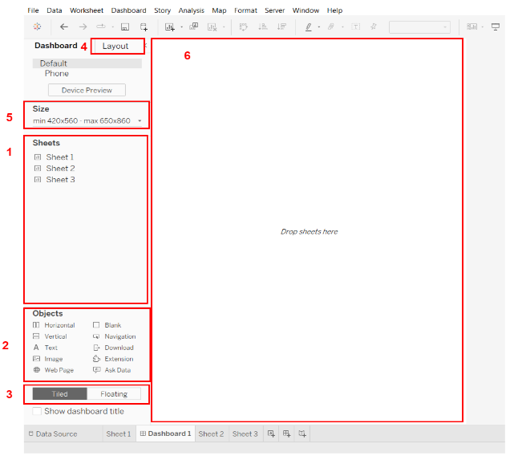

#### **Building a Dashboard**

Demo : <https://www.tableau.com/learn/tutorials/on-demand/getting-started-part9?playlist=391099>

### **Dashboard Objects**

* Tableau Public has several different layout objects that you can add to your dashboard to control the composition.
* Containers allow you to essentially group dashboard objects together
* Show/Hide container buttons within dashboards help to declutter the view and make it easier to understand the data.(demo added)

Demo :

* Using the sample superstore data create a visualization (map type) showing state wise sales.
* In another worksheet, drop Region and state to the Rows shelf and drop sales to labels in the Marks card.
* Create a new dashboard. Set size to automatic.
* Select Tiled

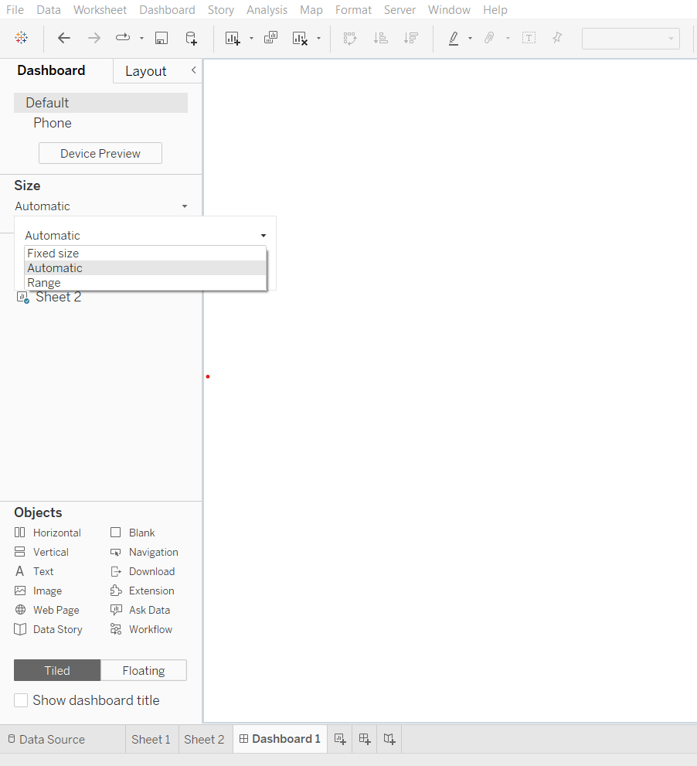

* Drop both Sheet 1 and Sheet 2 on the canvas.
* Two containers have been created. Open the menu of a container from its top-right and select ‘Add show/hide button.’
* Right click on the button and choose the sheet.
* Alt + Click on the button will show or hide the container

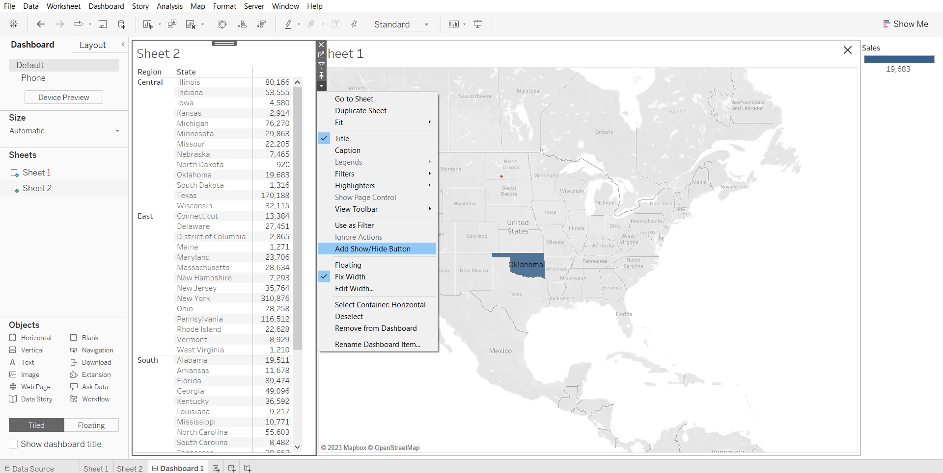

The following objects can be added to your dashboard: (demo of each has been added below)

* Horizontal layout containers: You can drag worksheets that you want next to each other into these containers. It has a Dark Blue border.
* Vertical layout containers: You can drag other objects and worksheets that you want to stack from top to bottom into these containers.It has a Dark blue border
* Text objects: These can be used to add titles and calls to action. Though you can’t add field tokens to text objects, you can add parameter tokens, which will be discussed in depth in the next chapter.
* Images: You can use these to browse logos or branding elements that add richness to your dashboard. You can also use images as links to web pages, since each image can have a URL attribute.
* Web page objects: These can be used to add content from the Internet. You can even create dynamic content.
* Blank objects: These objects can be used to control space. Blank containers are transparent. So, the background colors that you are using will show through them.
* Extension: Extensions let you add unique features to dashboards or directly integrate them with applications outside Tableau. Adding extensions is easy; you incorporate them into dashboard layouts just like other dashboard objects. Extensions expand dashboard functionality with the help of web applications created by third-party developers.
* Navigation Object: Lets your audience navigate from one dashboard to another, or to other sheets or stories.

#### **Dashboard Objects Demonstrations**

Creating 3 sheets that will be used to explain the all concept.

1. Sheet 1: Monthly sales for each years

* Drag order date to columns shelf
* From its dropdown select ‘month with year’
* Drop sales on rows shelf
* Rename sheet to Monthly sales for each year

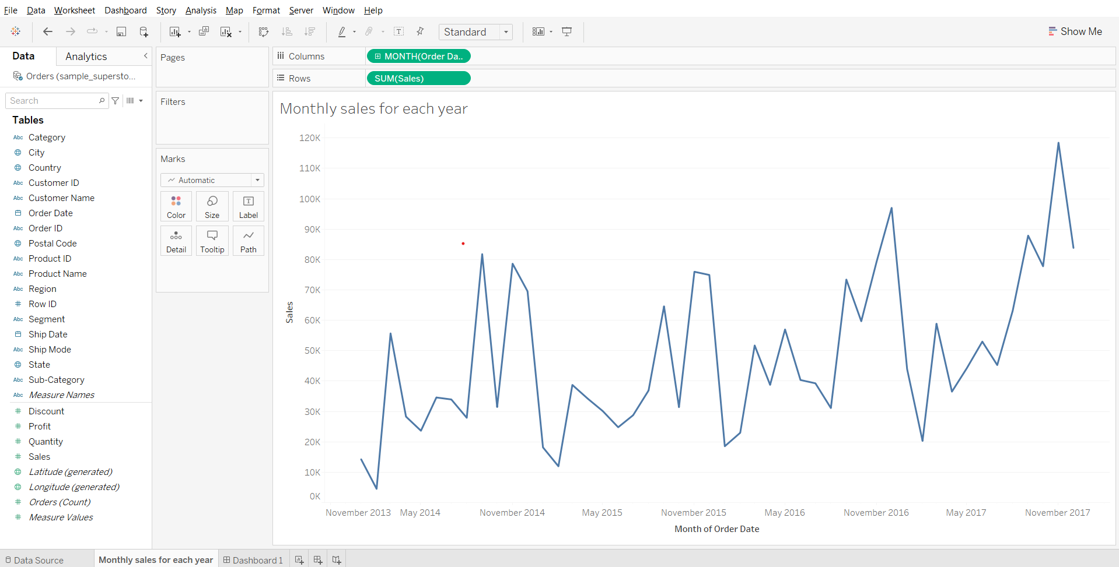

1. Sheet 2: Summary Table

* Drag measure names to columns shelf
* Drag measure values to text on marks card
* From measure values card, remove CNT(Orders), SUM(Discount) and SUM(Quantity)
* In measure values card, reorder sales to above profit.

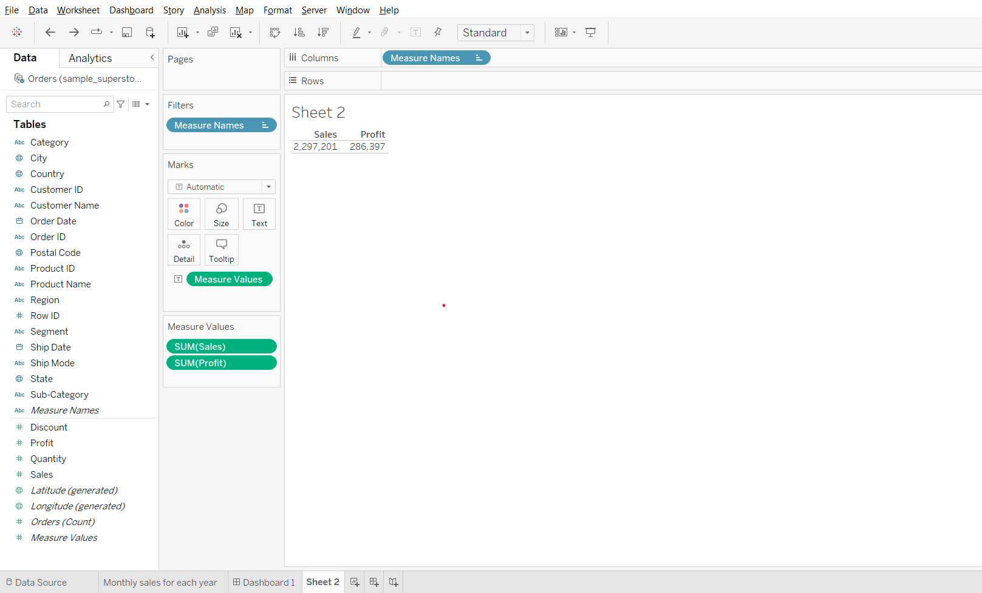

* Drop Order Id to details in marks card, change its measure to count distinct.
* Drag CNTD(Order ID) to measure values card
* Drop Customer Name of text in the Marks card and change its measure to count distinct.
* Drag CNTD(Customer Name) to measure values card
* Change Fit to ‘Entire View’
* Right click on the header in the sheet and uncheck ‘Show Header’ option.

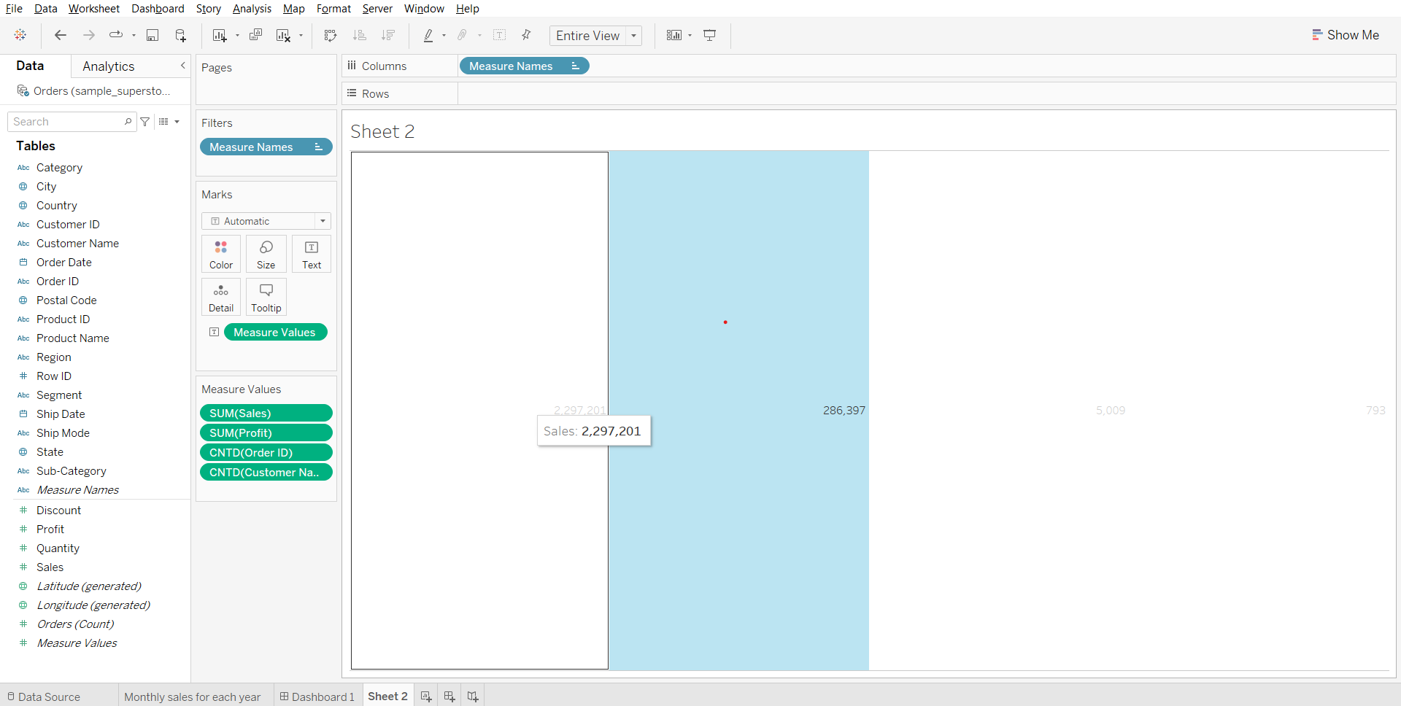

* Drag measure names to text in marks card
* Double click on text in the Marks card, open the dialog box.
* Select Measure Values, change size to 16. Click ok.
* Change sheet name to ‘summary table’

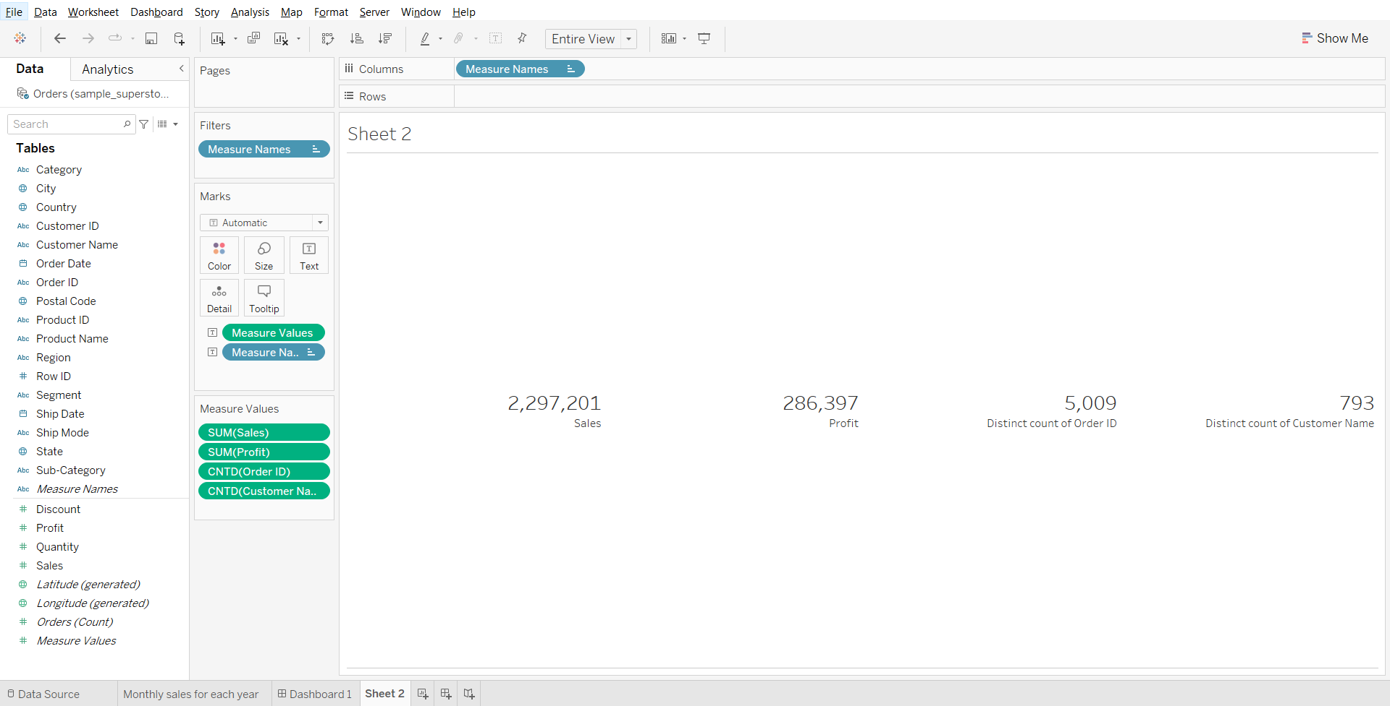

1. Sheet 3: Sub-category wise sales

* Drag sub-category to rows
* Drag sales to columns
* Rename sheet to sub-category wise sales.

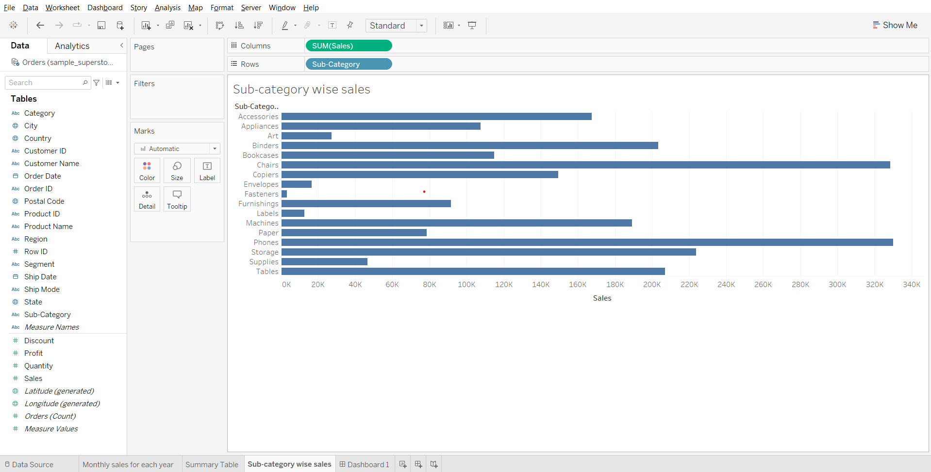

#### **Creating a Dashboard using the Horizontal container**

* Create a new dashboard tab, select tiled.
* From objects, drag horizontal to the canvas.
* Drag the 1st sheet to roughly the centre of the canvas.
* Drag the 2nd sheet to the right end, then drag the 3rd sheet to the right end.

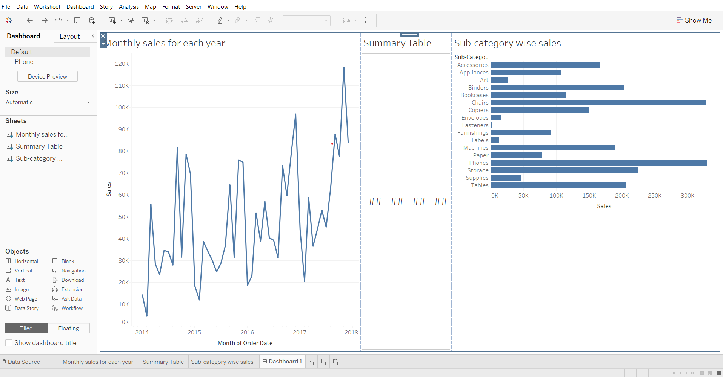

* Go to the layout tab in the left pane.
* In Item Hierarchy, click on Horizontal.
* From the top left corner of the blue box (horizontal container) that shows, open the menu and select distribute contents evenly.
* Select the third sheet and change fit to the entire view.

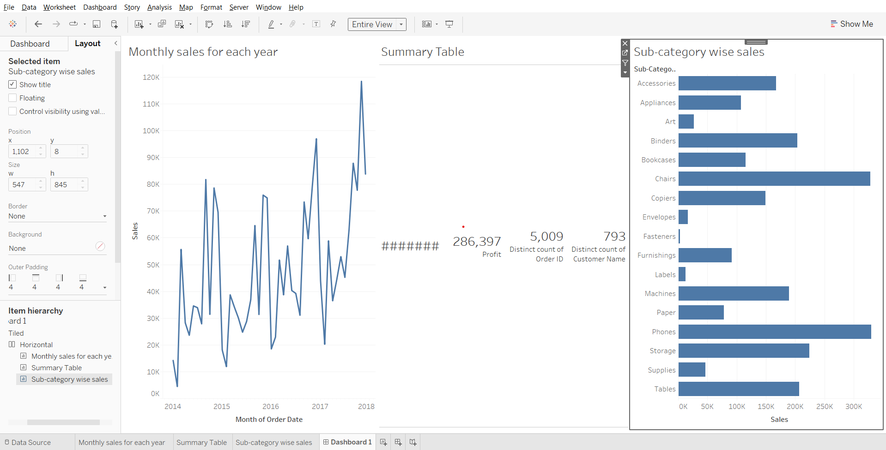

#### **Creating a Dashboard using the Vertical container**

* Create a new dashboard and drag ‘vertical’ from ‘objects’ to the canvas
* Set size to automatic
* Drag the 1st sheet to roughly the centre of the canvas.
* Drag 2nd and 3rd sheets to the bottom, be careful not to drop them outside the vertical container.
* Go to layout, click on ‘vertical’ in the item hierarchy section.
* Open the menu from top left corner of the vertical container, select Distribute Content Evenly

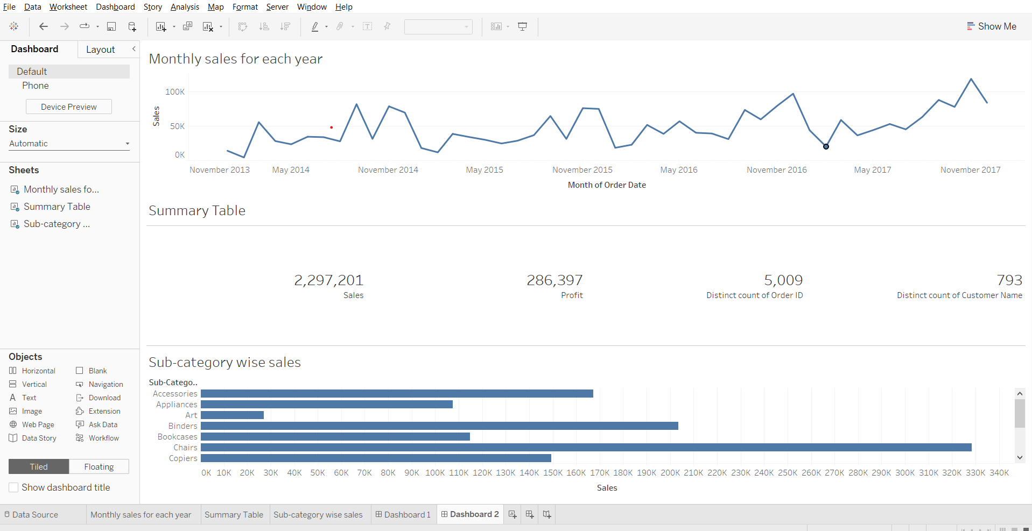

#### **Image object**

Using an image object we are using a floating container.

* Click on floating, drag the image from objects to the canvas.
* In the box, choose an image, click OK.

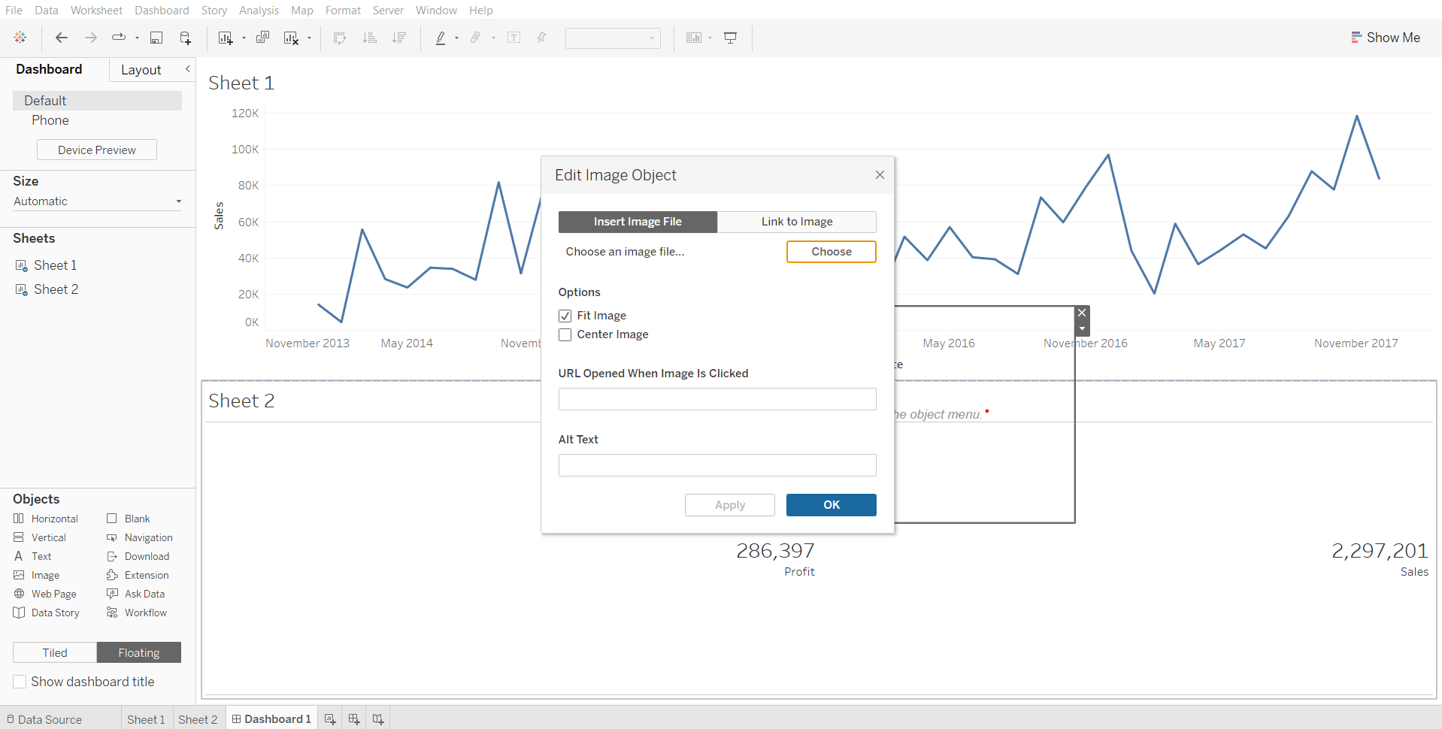

Position the image as needed.

#### **Web Page object**

Click on tiled, drag ‘web page’ from objects to the bottom of the canvas. Enter the url, say ‘[www.scaler.com](http://www.scaler.com)’.

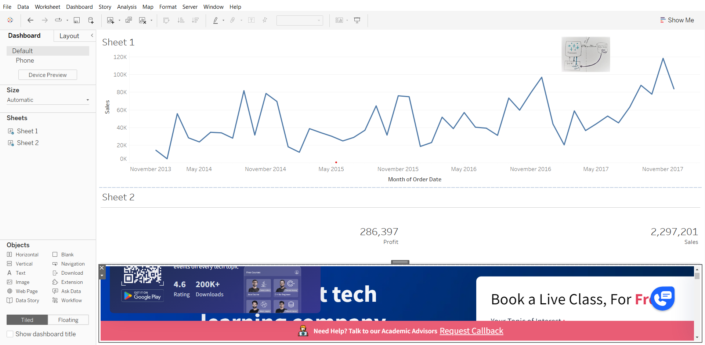

**Interactive Dashboards with actions**

To make your visuals interactive in Tableau is to use a series of actions :

* [**Filter action**](https://help.tableau.com/current/pro/desktop/en-us/actions_filter.htm) - Use the data from one view to filter data in another to help guide analysis
* [**Highlight action**](https://help.tableau.com/current/pro/desktop/en-us/actions_highlight_advanced.htm) - Call attention to marks of interest by coloring specific marks and dimming all others.
* [**Go to URL action**](https://help.tableau.com/current/pro/desktop/en-us/actions_url.htm) - Create hyperlinks to external resources, such as a web page, file, or another Tableau worksheet.
* **Go to sheet action** - Simplify navigation to other worksheets, dashboards, or stories.
* **Change Parameter action** - Let users change parameter values by directly interacting with marks on a viz.
* **Change set values** - Let users change the values in a set by directly interacting with marks on a viz.

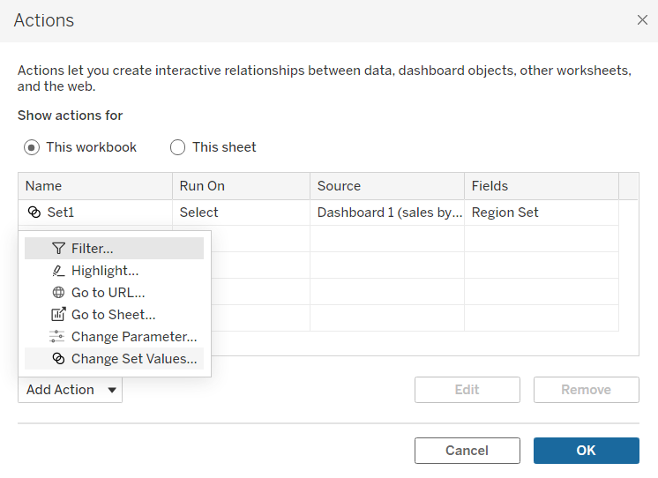

#### **Change Parameter action demonstration:**

Using parameter action to choose chart type - [video link](https://youtu.be/2plhzaXODSQ?t=232)

To use custom icons download the icons that you want and save it in this location -

\Documents\My Tableau Repository\Shapes

**Icons**

Bar chart icon  
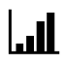

Line chart icon-  


Map icon  


#### 

#### 

#### **Change set values:**

Demo:  
Display what proportion each region contributed to total monthly sales for each year using set action.

1. Displaying total sales for each region
   * Drop sales on rows shelf
   * Drop region on columns shelf
   * Rename sheet to sales by region

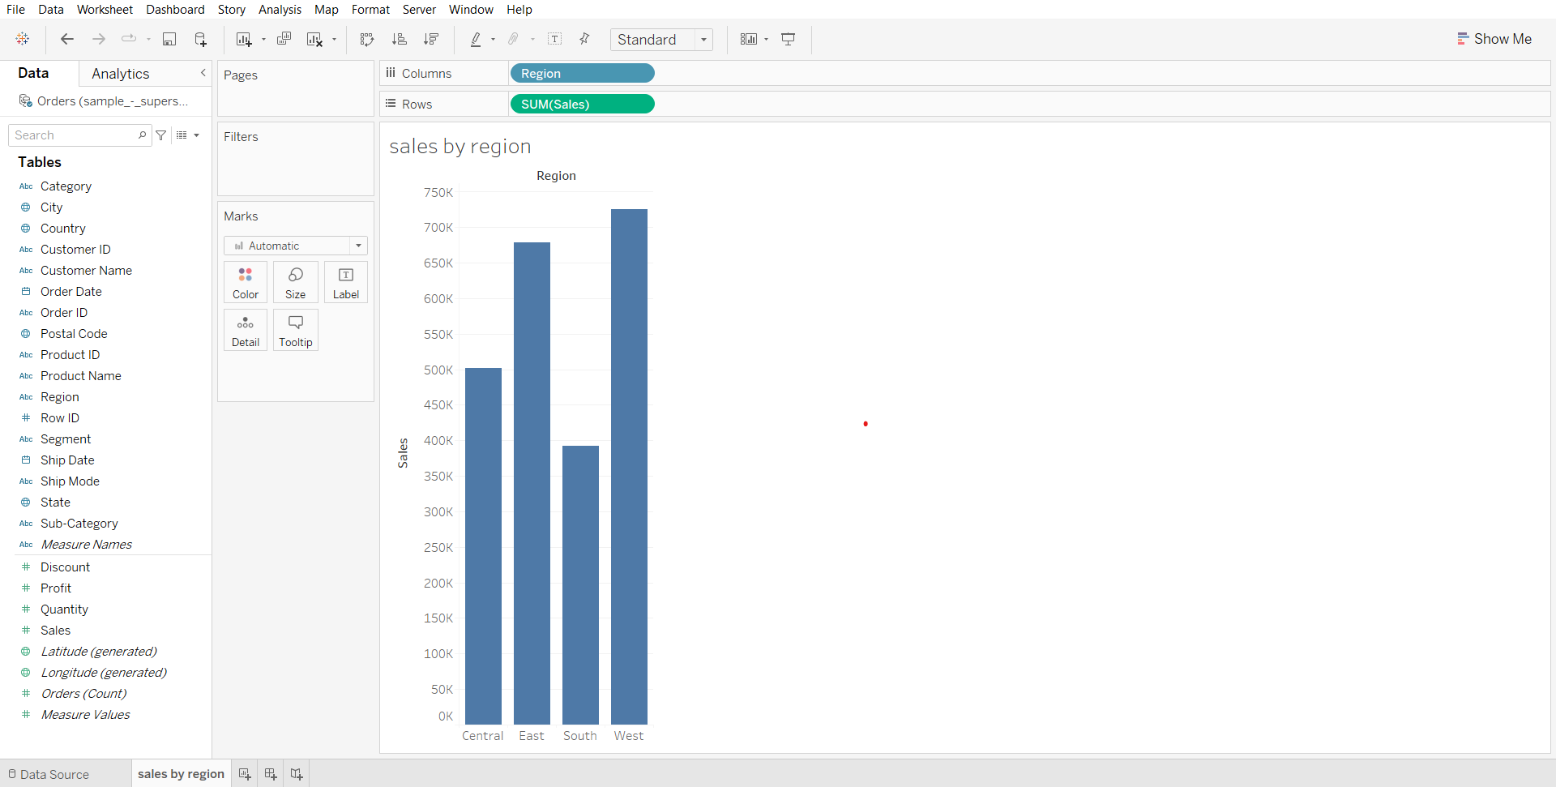

1. Displaying monthly sales data for each year
   * Drag Order Date to columns shelf
   * Click on the small plus to get quarters
   * Open Quarter(Order Date) dropdown and select month (without year)
   * Drag sales to rows
   * Rename the sheet to ‘monthly sales for each year’

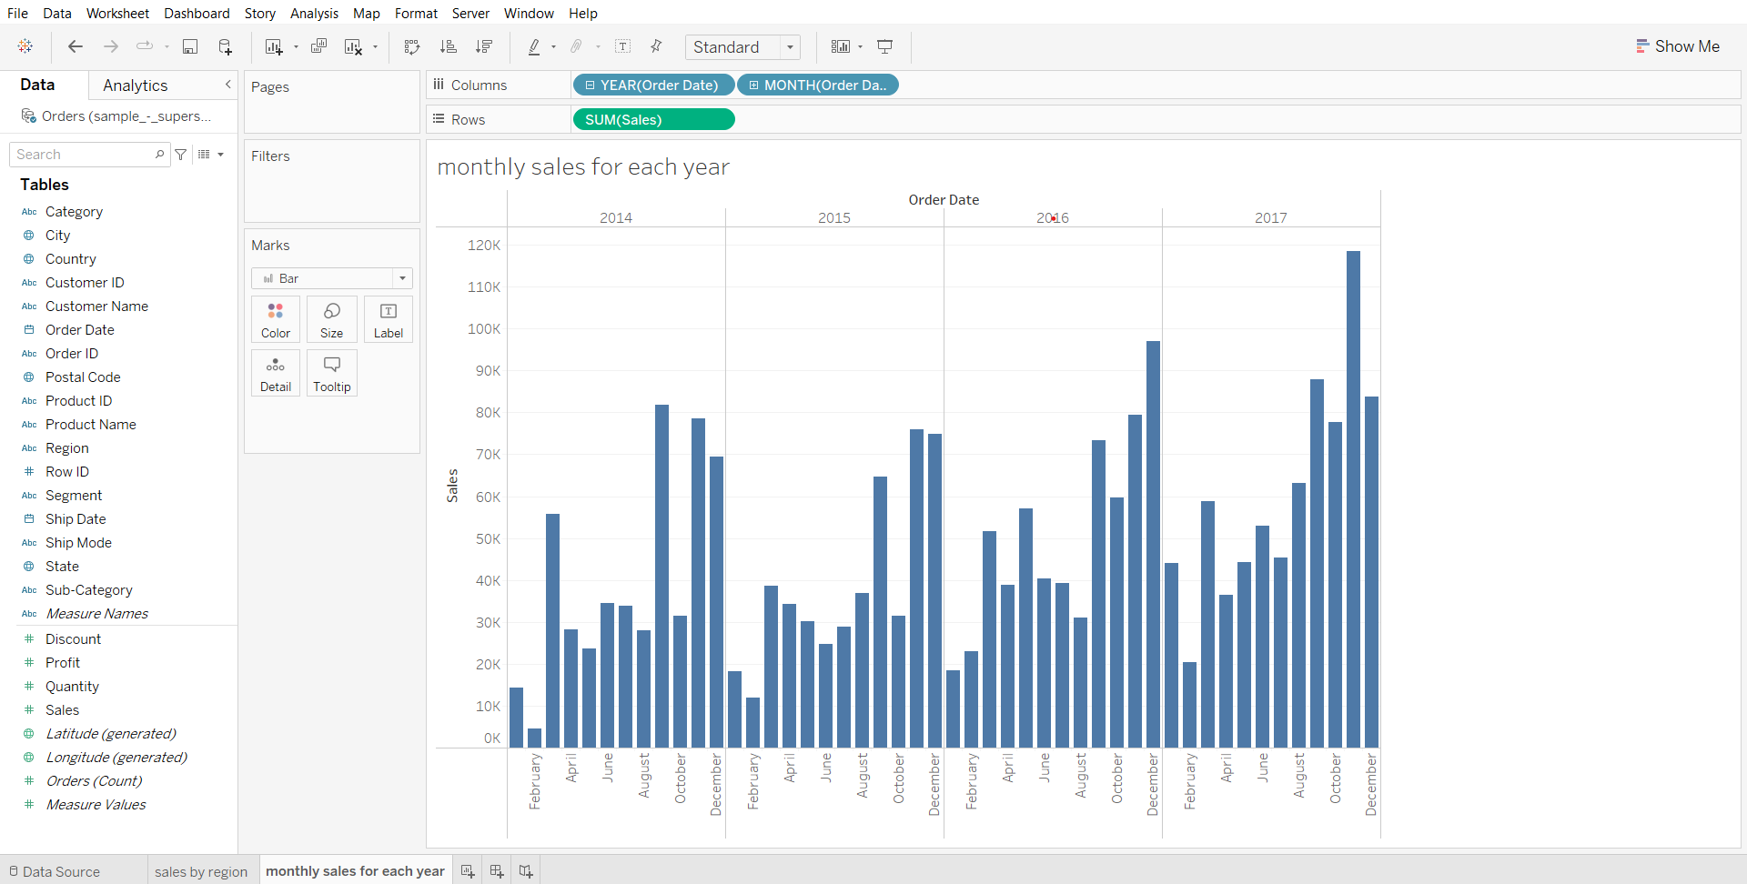

1. Creating an empty set for region field
   * Open the sales by region worksheet
   * Go to region in data panel, open its dropdown, go to Create > Set
   * In the dialog box, click ok.

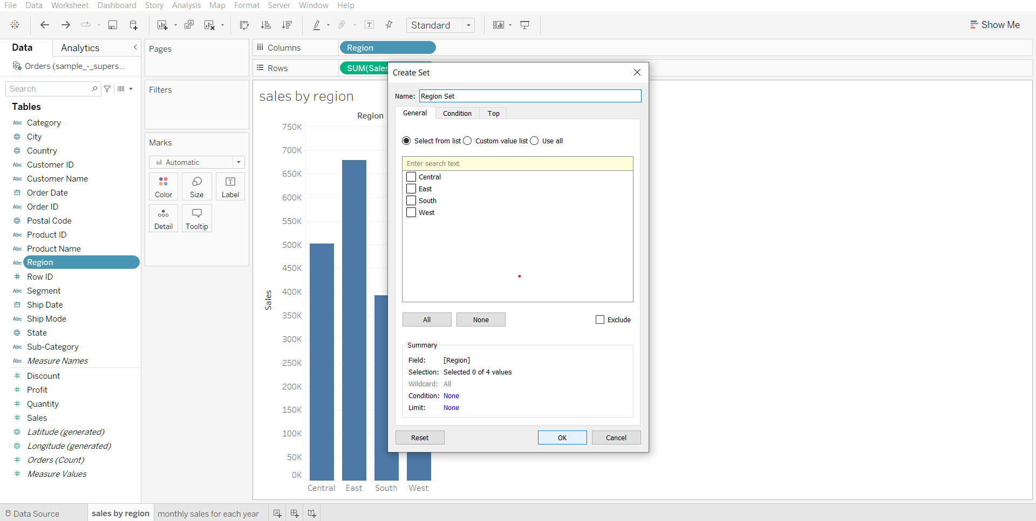

1. Adding newly created set to the time series graph and nothing is present in this set currently hence everything is in gray color
   * Go to ‘monthly sales for each year’ sheet, drop region set on color in marks card
   * Open the In/Out(Region) dropdown from the marks card, click on Sort
   * Click on Descending, then click on ascending, close the dialog box.

Here we are sorting the result of it will be visible in the final dashboard such that the selected region values will be displayed at the bottom rather than on top.

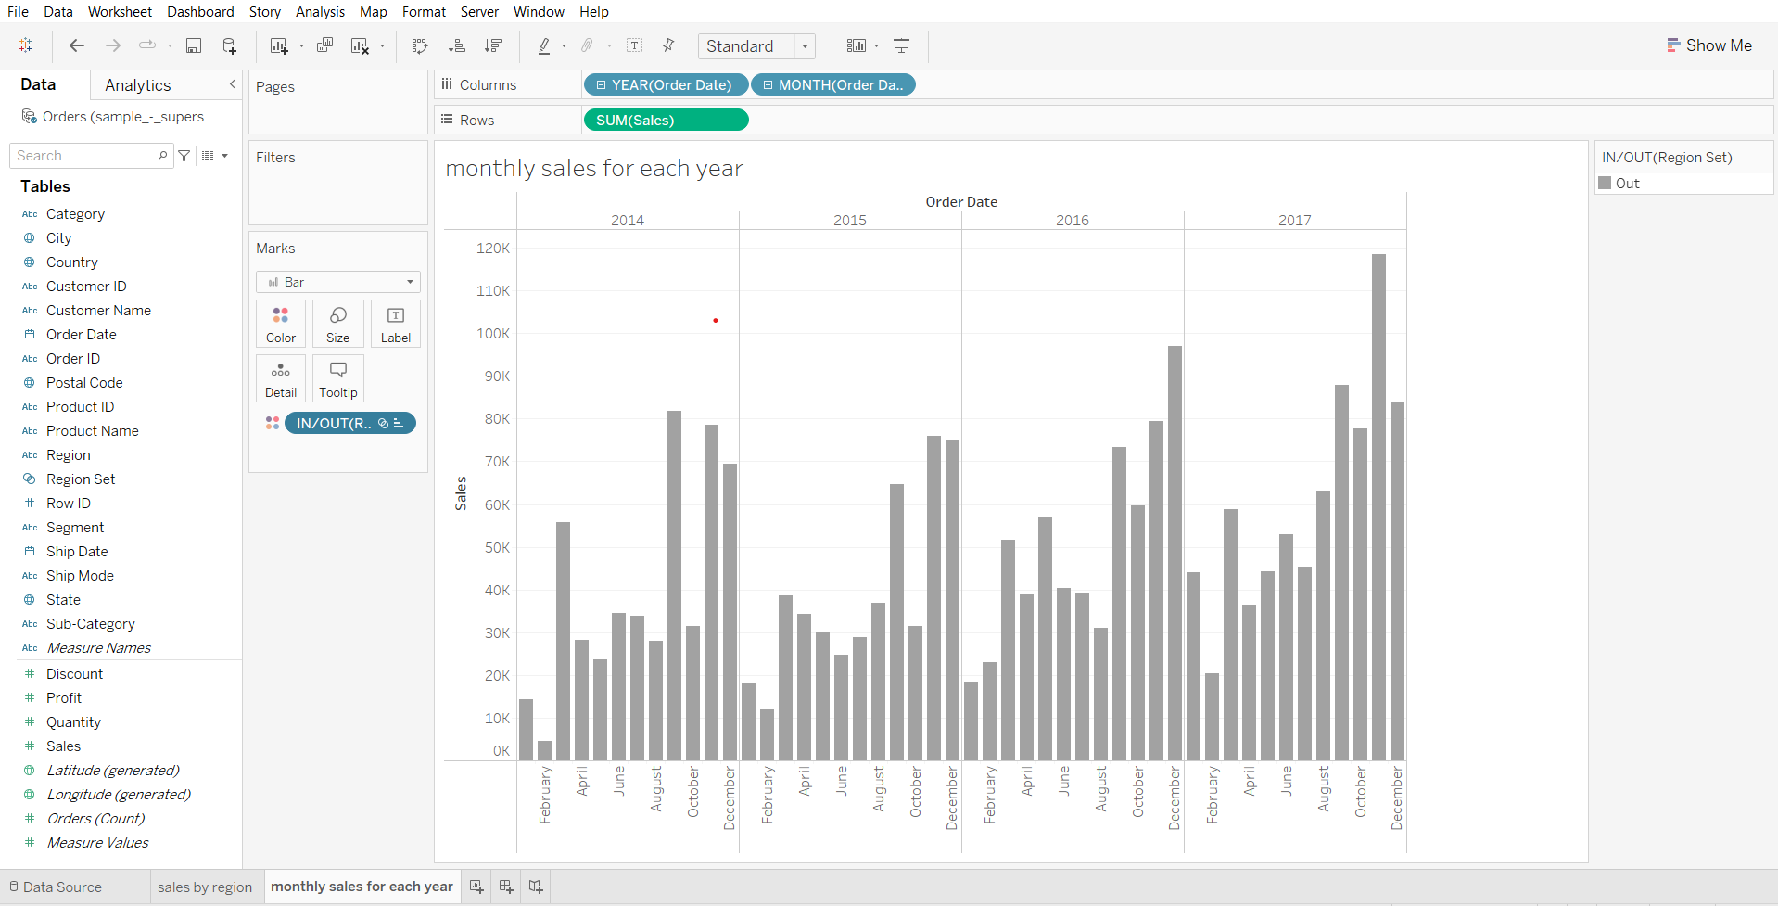

1. Creating a Dashboard
   * Create a new dashboard
   * Drag sales by region to the canvas
   * Drag monthly sales for each year to the right of the canvas
   * Set size to automatic

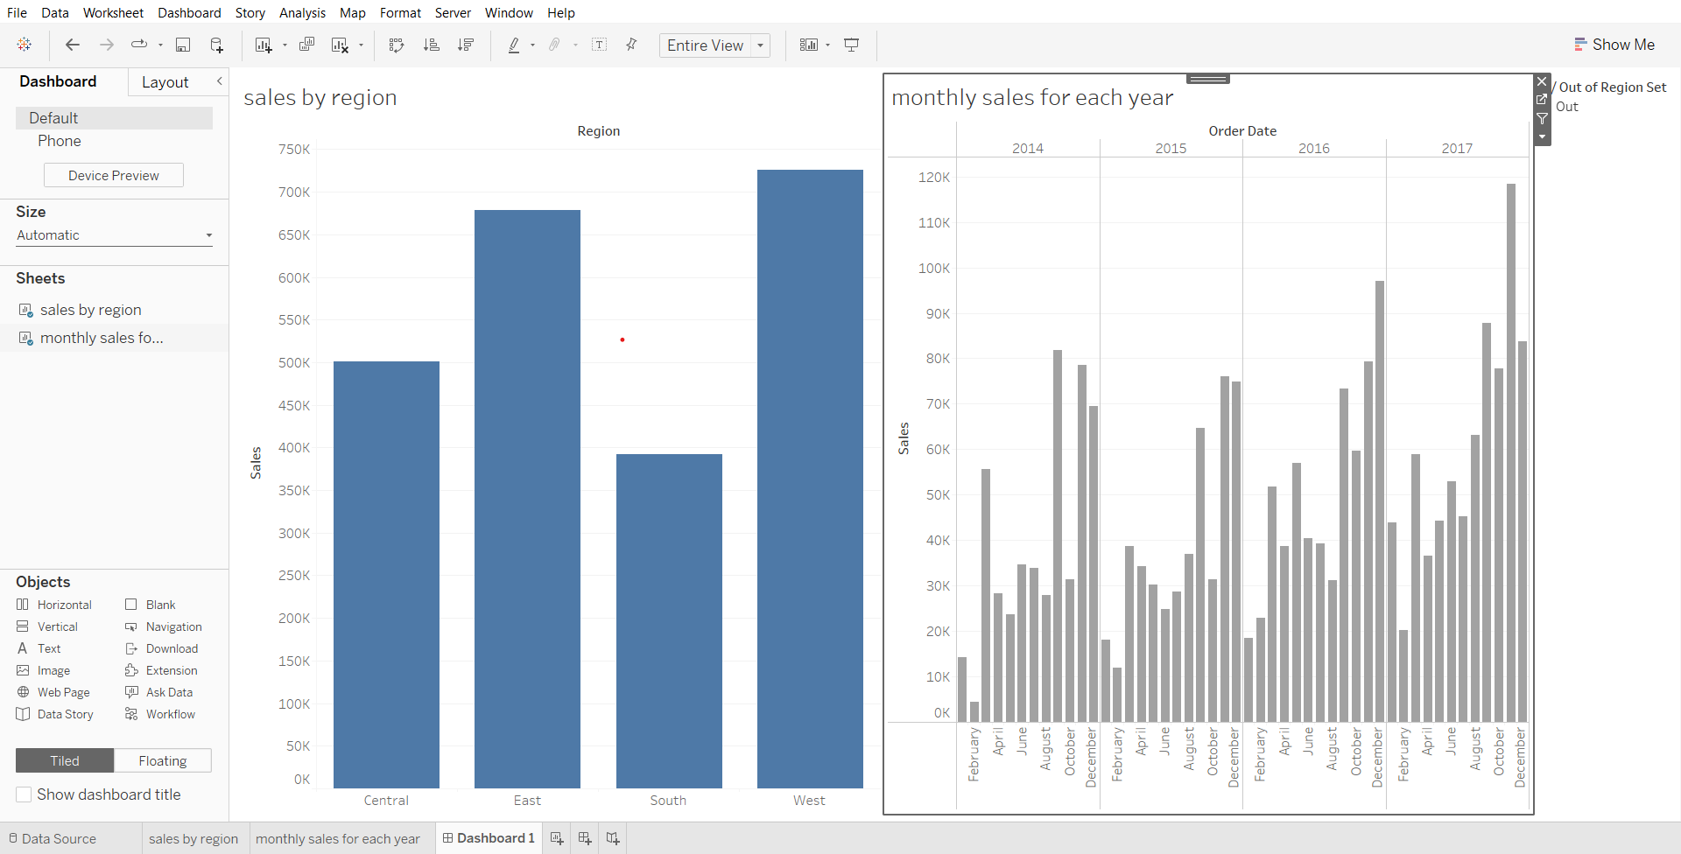

1. Creating Set action in Dashboard and solving the business problem
   * In the Dashboard menu (from menu bar) click on Actions…
   * Click on Add Action and select ‘Change Set Values’
   * In the new dialog box, deselect ‘monthly sales for each year’ in source sheet
   * In target set, select orders(sample superstore) > Region set.
   * Change ‘clearing the selection will’ to ‘remove all values from set’
   * Click ok in both boxes.
   * You can change the colors used in ‘monthly sales for each year’ by going to the sheet, clicking on color in the marks card and choosing Edit colors…

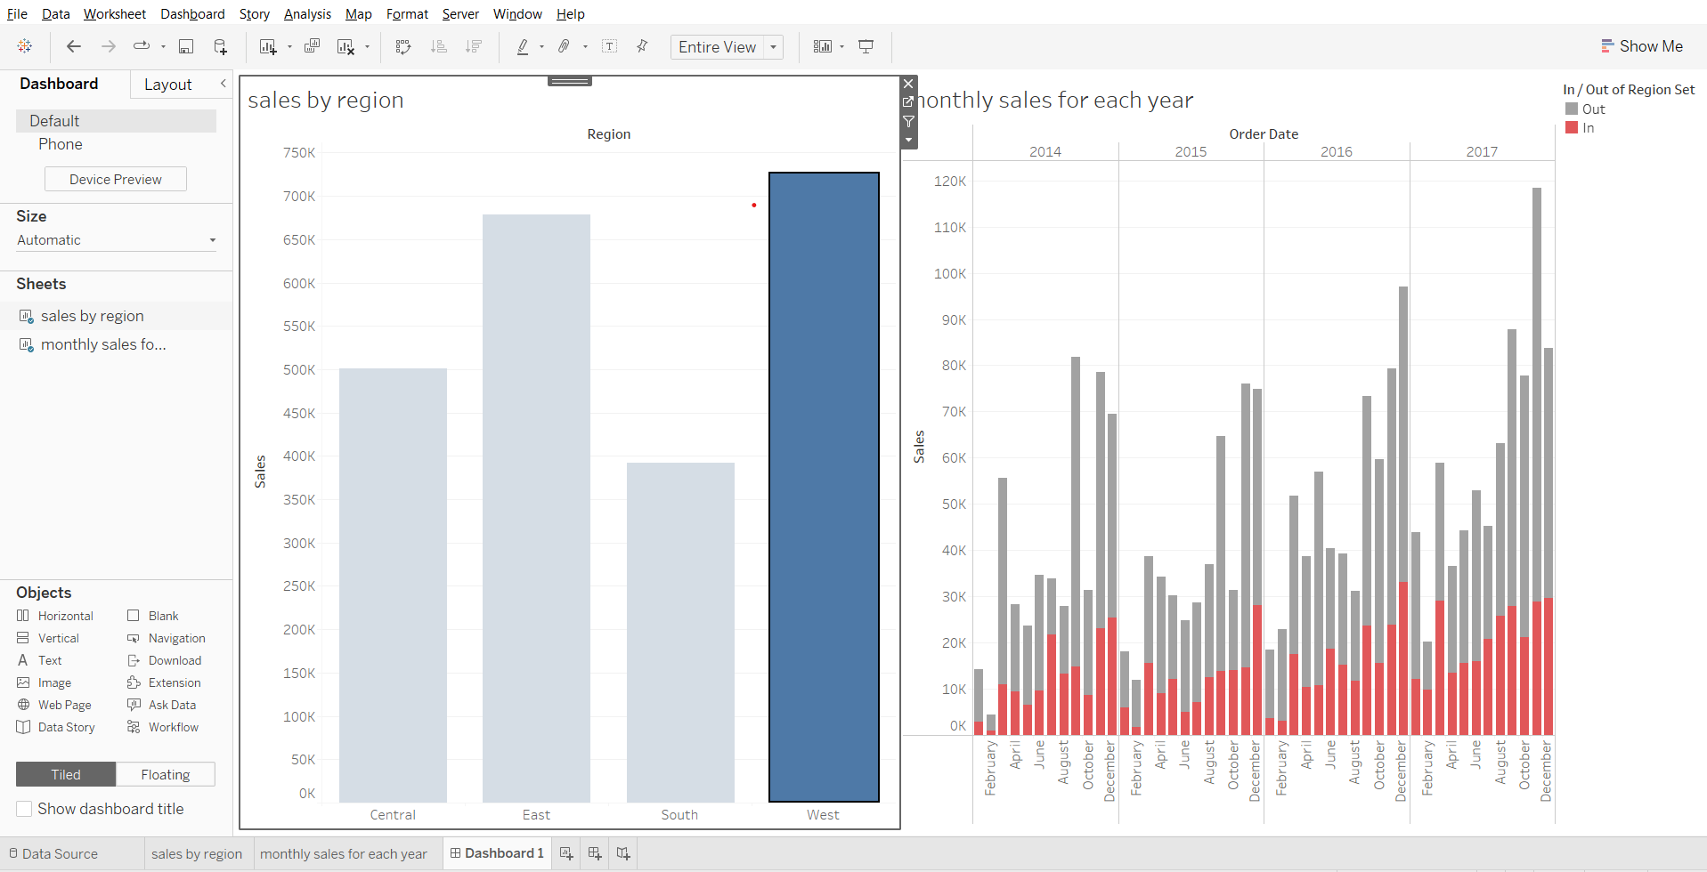

**Filters Action**

Demo:  
Filter Out sales of products based on categories and subcategories

1. Creating Bar chart to visualize sales for each category
   * Drag sales to rows shelf
   * Drag category to columns shelf
   * Drag category to color in marks card
   * Rename sheet to sales by product category

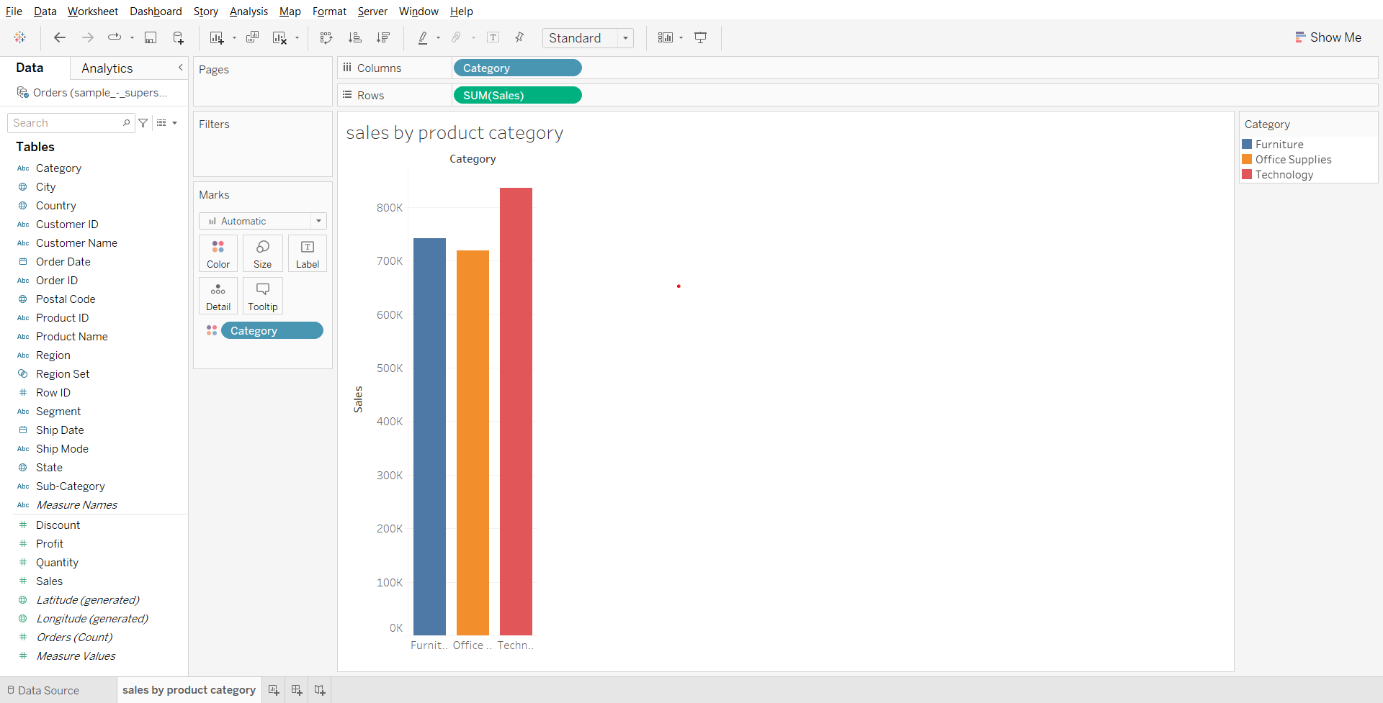

1. Creating Bar chart to visualize sales for each sub category
   * Create a new worksheet, name it ‘sales by sub-category’
   * Drag sales to rows shelf
   * Drag category to columns shelf
   * Drag sub-category to columns shelf
   * Drag category to color in marks card

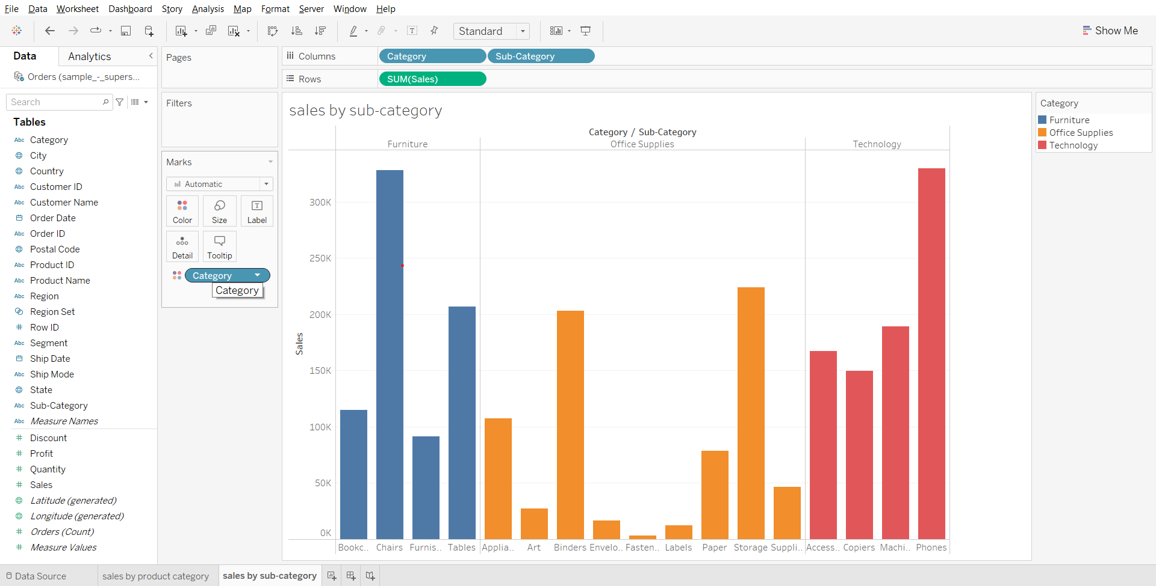

1. Creating Filter action and solving business problem in a worksheet
   * Go to the worksheet in the menu bar, click on Actions…
   * From Add Action, select Filter
   * In the box that appears, select ‘sales by product category’ as source sheet
   * Select ‘sales by subcategory’ as target sheet
   * In ‘run action on’ section choose ‘select’ and check ‘single-select only’
   * In ‘clearing the selection’ section choose ‘show all values’. Click ok in both boxes.
   * Go to the ‘sales by product category’ sheet and click on any of the 3 bars in the chart. Observe the change in target sheet ‘sales by sub-category’.

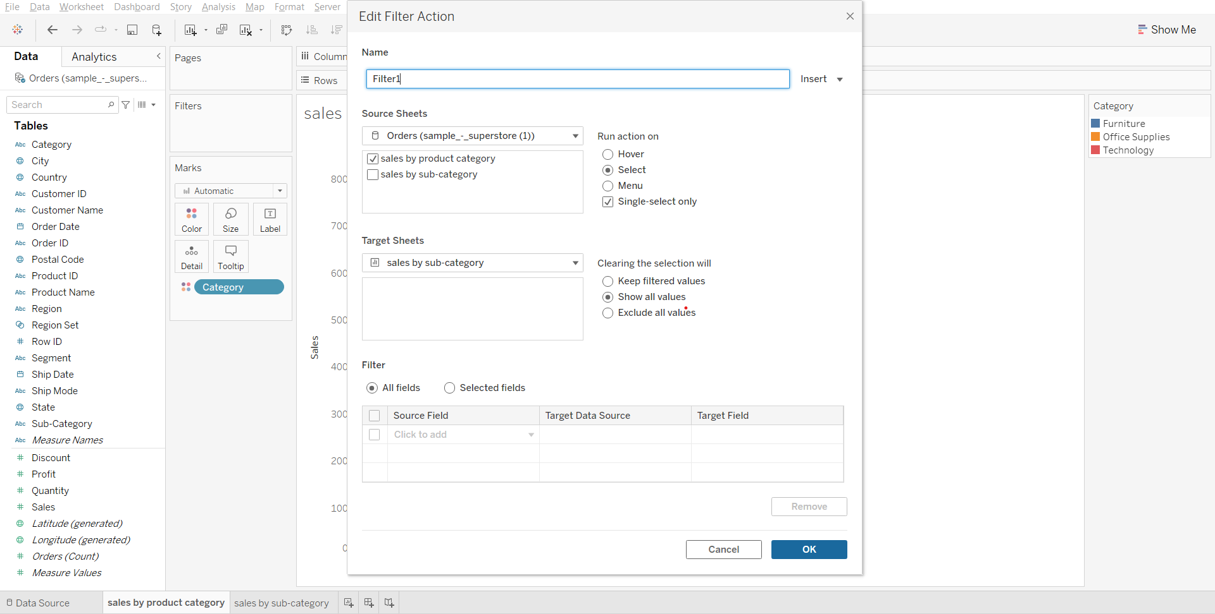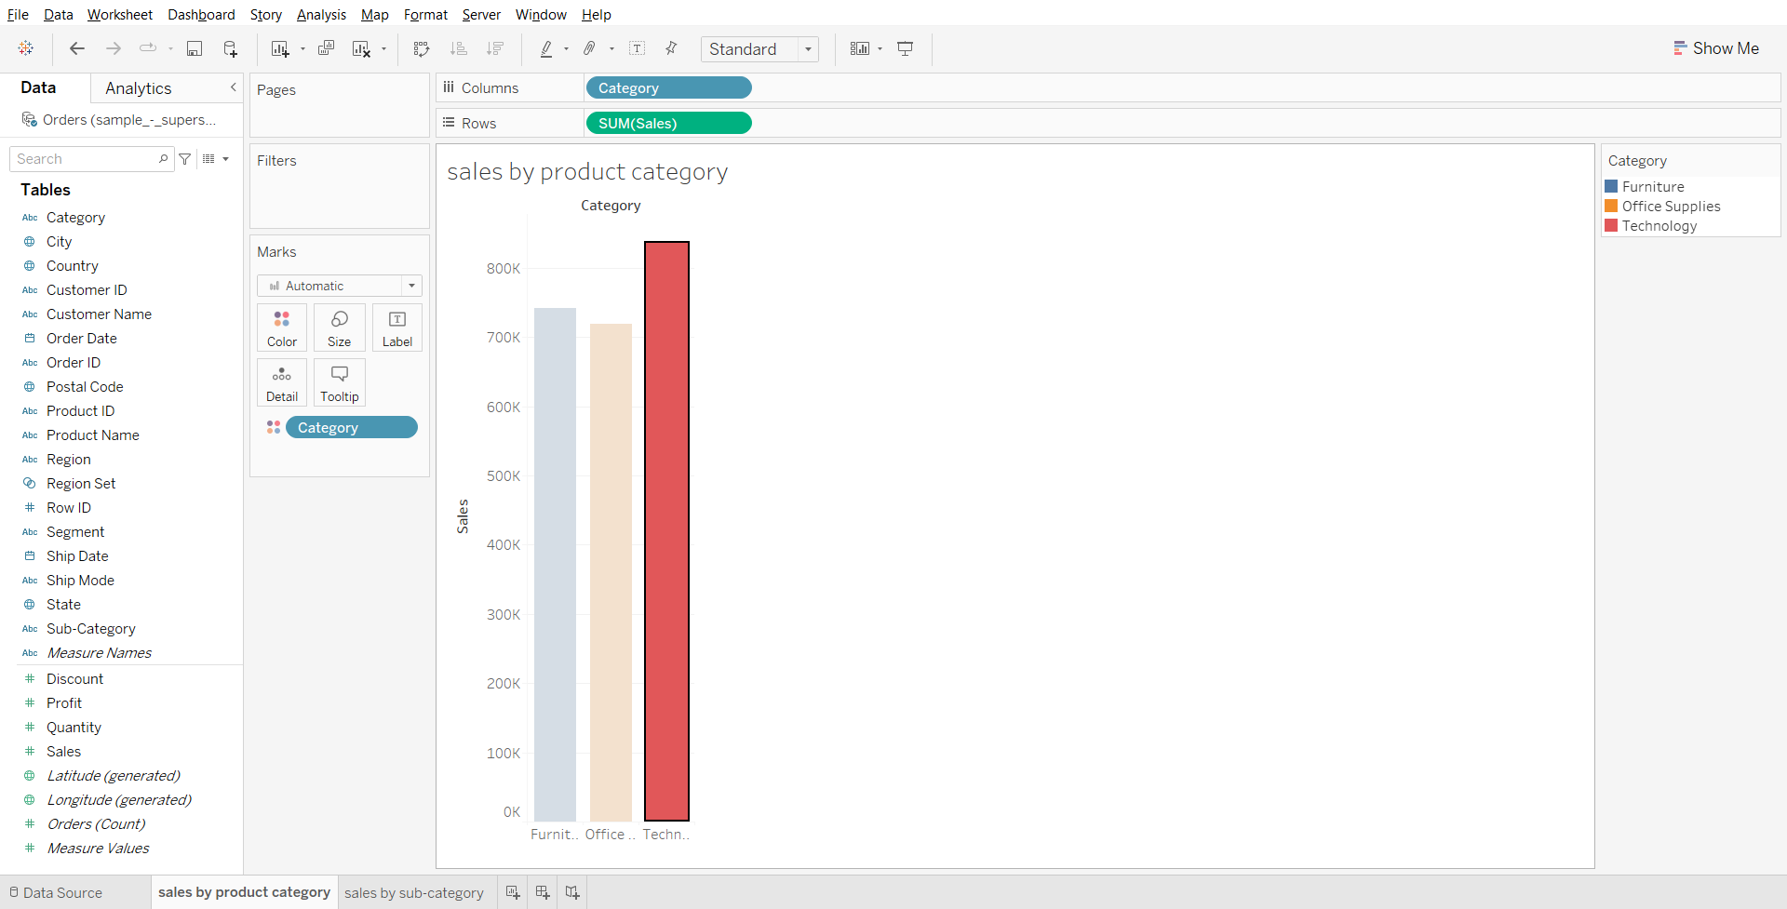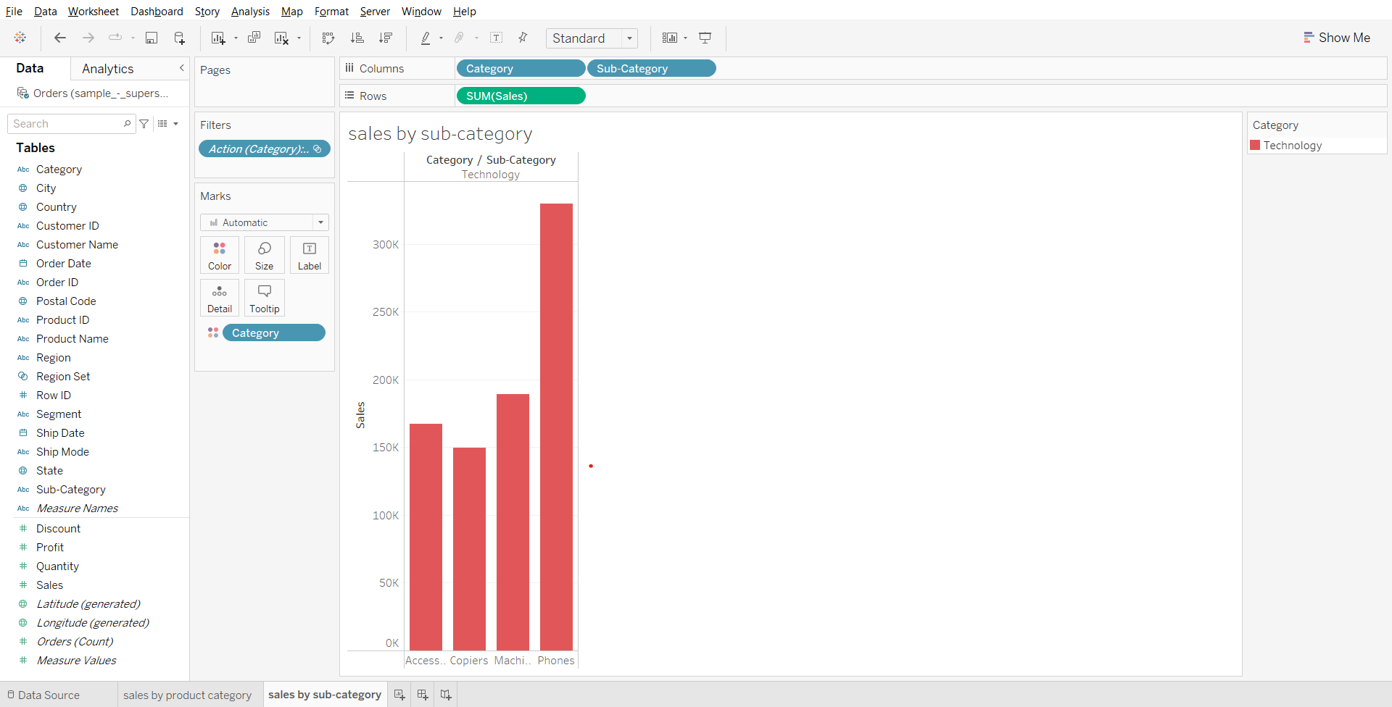

1. Creating a Dashboard
   * Create a new dashboard
   * Drag sales by product category to the canvas
   * Drag sales by subcategory to the right side of canvas, but left of the legend (because both charts have the same legend).
   * Set size to automatic.

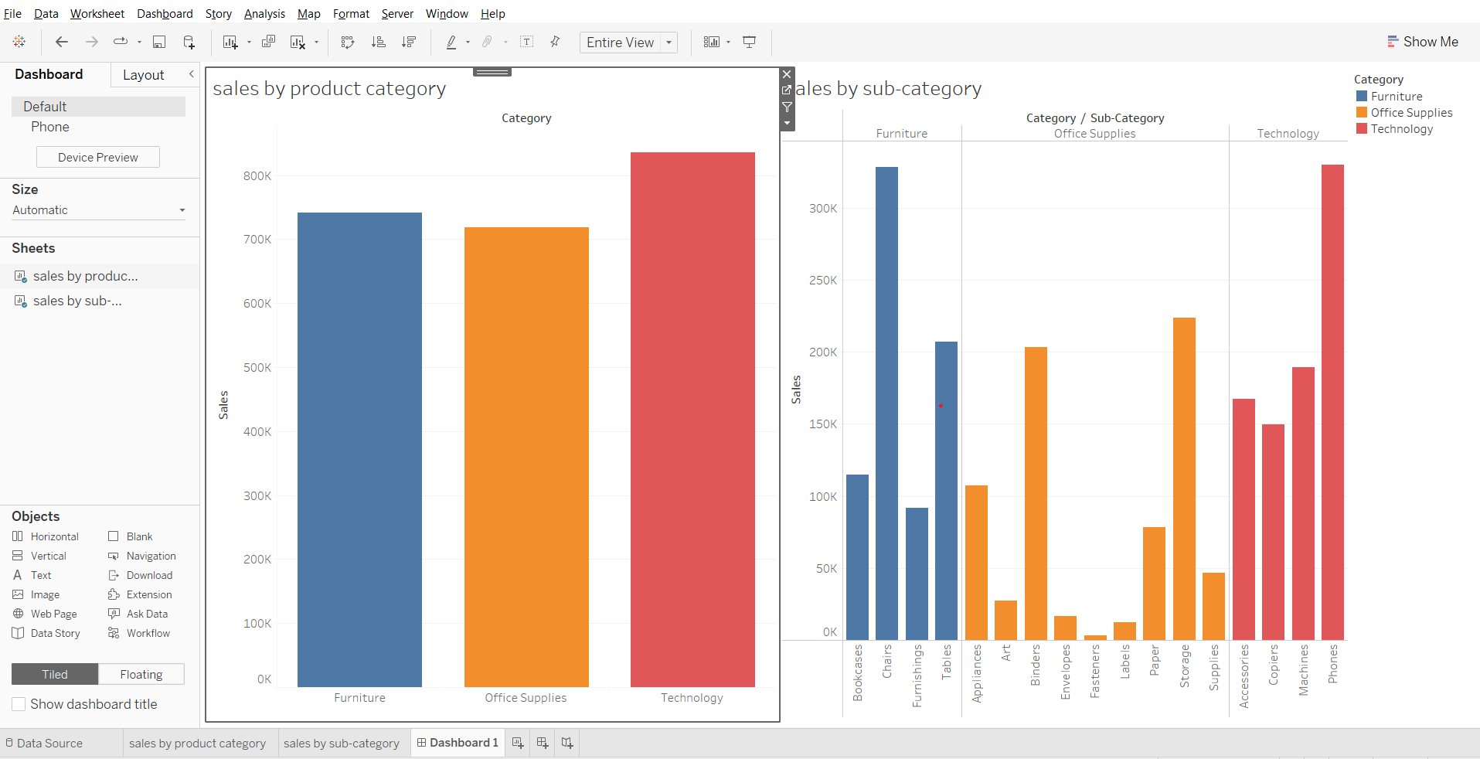

**Demo in Dashboard :**

* In the dashboard created above, go to the dashboard in the menu bar, click on Actions…
* In Add Action, select filter
* In source sheets, select Dashboard 1, then select both the sheets.
* Rest of the steps are the same as the previous filter. (See screenshot below)
* Click on different bars in the ‘sales by product category’ container to see the results.

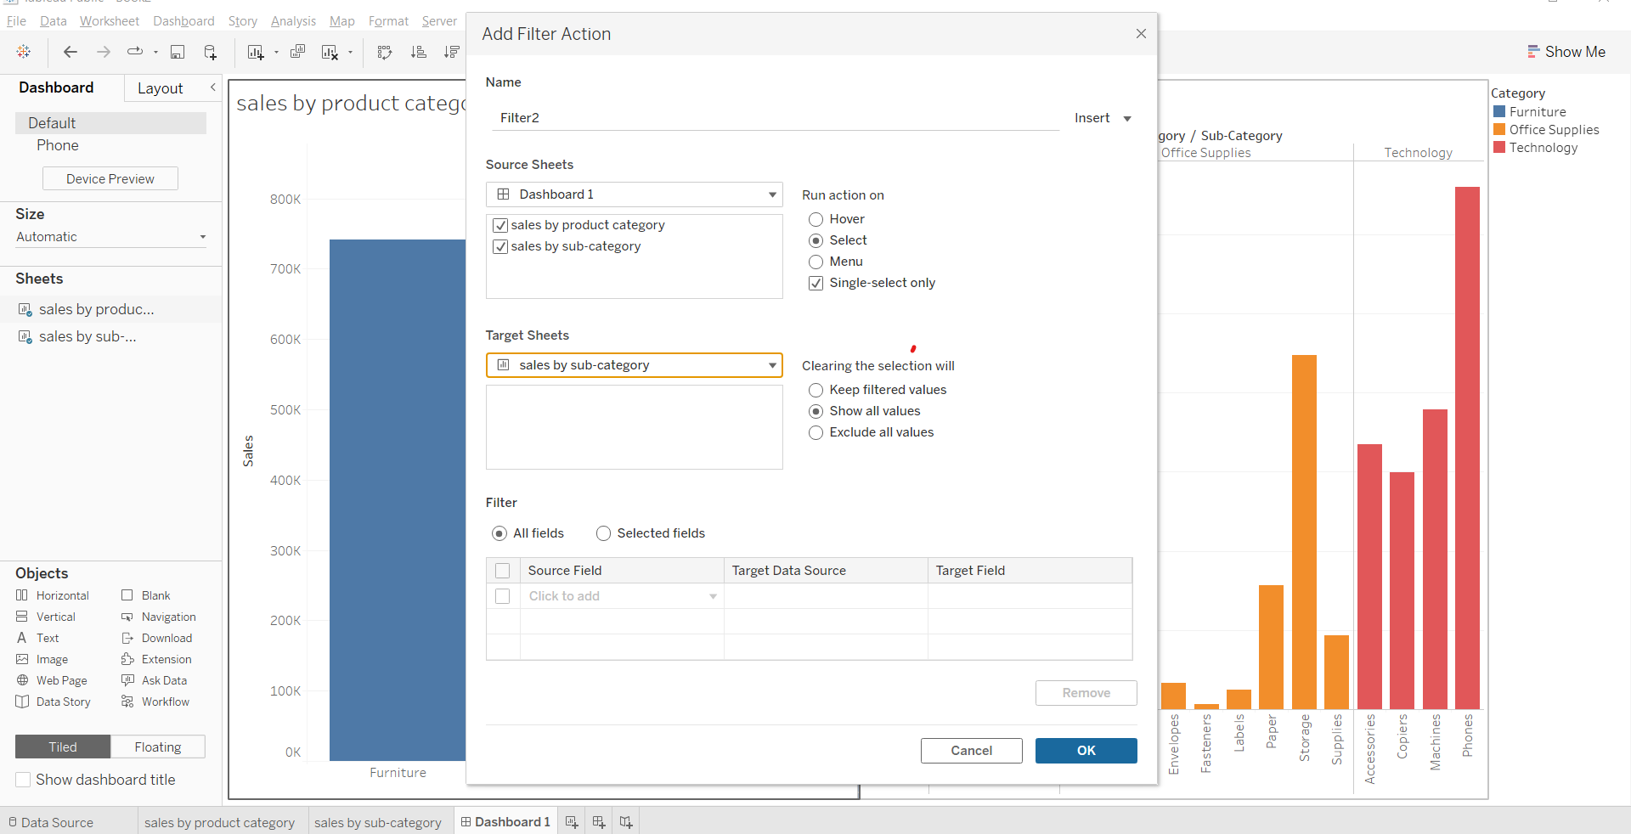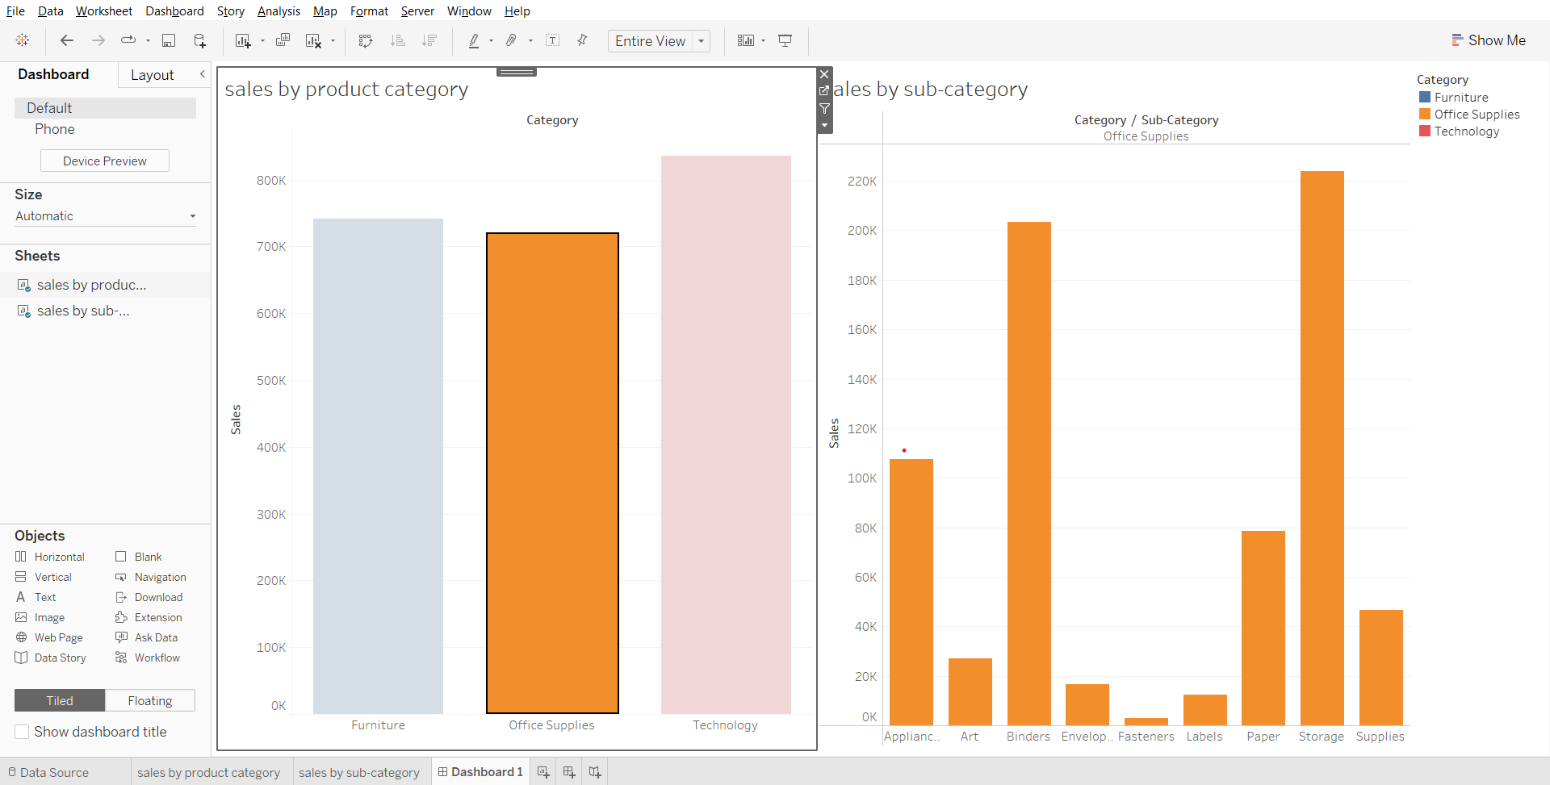

**Story Points**

* Use stories to make your case more compelling by showing how facts are connected, and how decisions relate to outcomes. You can then publish your story to the web, or present it to an audience.
* Each story point can be based on a different view or dashboard, or the entire story can be based on the same visualization seen at different stages, with different filters and annotations

Demo :Open a new story tab.

* The sheets and dashboards created earlier are shown in the left pane.
* Drag a sheet on the canvas
* Click on ‘Blank’
* Drag another sheet on the new canvas.
* Write a caption for the 2 story points.
* Go to layout and pick a desired navigation style.

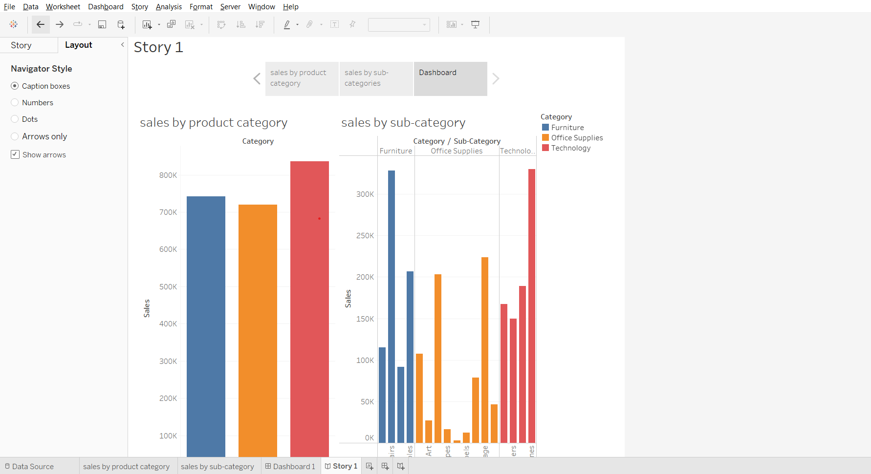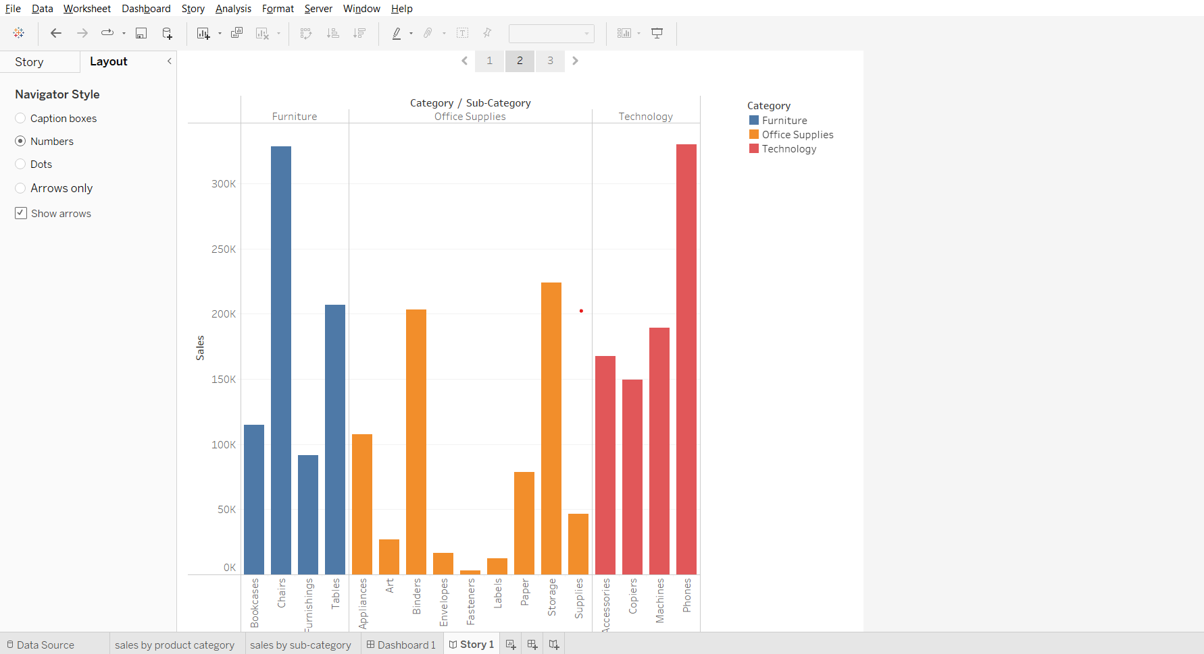

### 

### **Dashboards and Stories (Business Problem)**

* Dashboard 1 :
  + Find out which state is losing money and get an overall picture/overall summary.
* Dashboard 2:
  + Find the City and the subcategory where it is losing money.
* Dashboard 3 :
  + For the selected city and subcategory, find why it is losing money.

**Story :**

* Summary - Find out which state is losing money and get an overall picture/overall summary
  + Answer : Texas
* What went wrong in Texas - Find the City and the subcategory where it is losing money
  + Answer : Houston & Binder
* Product Analysis - Analysis of the products under the category Binder if they are all losing money
  + Answer : Yes
* Why so? – For the selected city and subcategory, why is it losing money?
  + Answer : All the products that are there in subcategory binder and for city houston it is giving an average discount of 0.8 or 80%

**Dashboard 1 :**

* Find out which state is losing money and get an overall picture/overall summary
  + Show overall summary for the profit and sales value as text
  + Show state wise profit and sales in single map (<https://youtu.be/x-k6PYernug>)
  + Display sales and profit for each subcategory using heat map
  + Have a Order date filter through which we can select year and the visualization will be updated based on the year selected

**Sheet1 -**Overall summary of Profit and sales for US.

* Drag measure names to columns
* Drag measure values to text in marks card
* From measure values card remove all measures except sales and profit
* Change fit to entire view
* Drag measure names to text in marks card
* Click on text in the Marks card, open the dialog box, change size of ‘measure values’ to 16.
* Click on text, change horizontal alignment to center.
* Right click on header, uncheck ‘show header’ option.

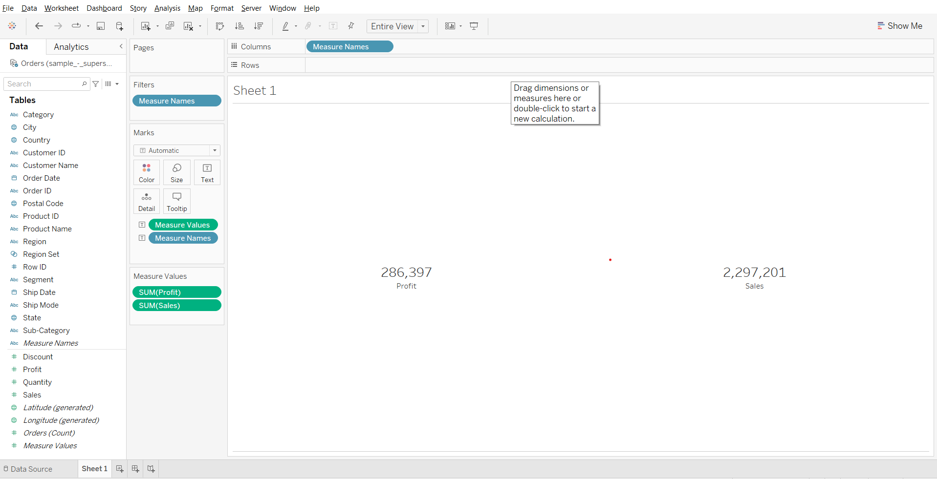

* Rename the sheet as summary

**Sheet 2 -**State wise profit and sales using map visualization.

* Drag longitude to columns
* Drag latitude to rows
* Drag state to detail in marks card
* Click on the ‘49 unknown’ box in the bottom right corner.
* Click edit locations, change country/region to from field > country. Click OK.
* Change chart type to map
* Drag Sales to color in marks card
* Drag latitude to rows shelf to get 2 graphs

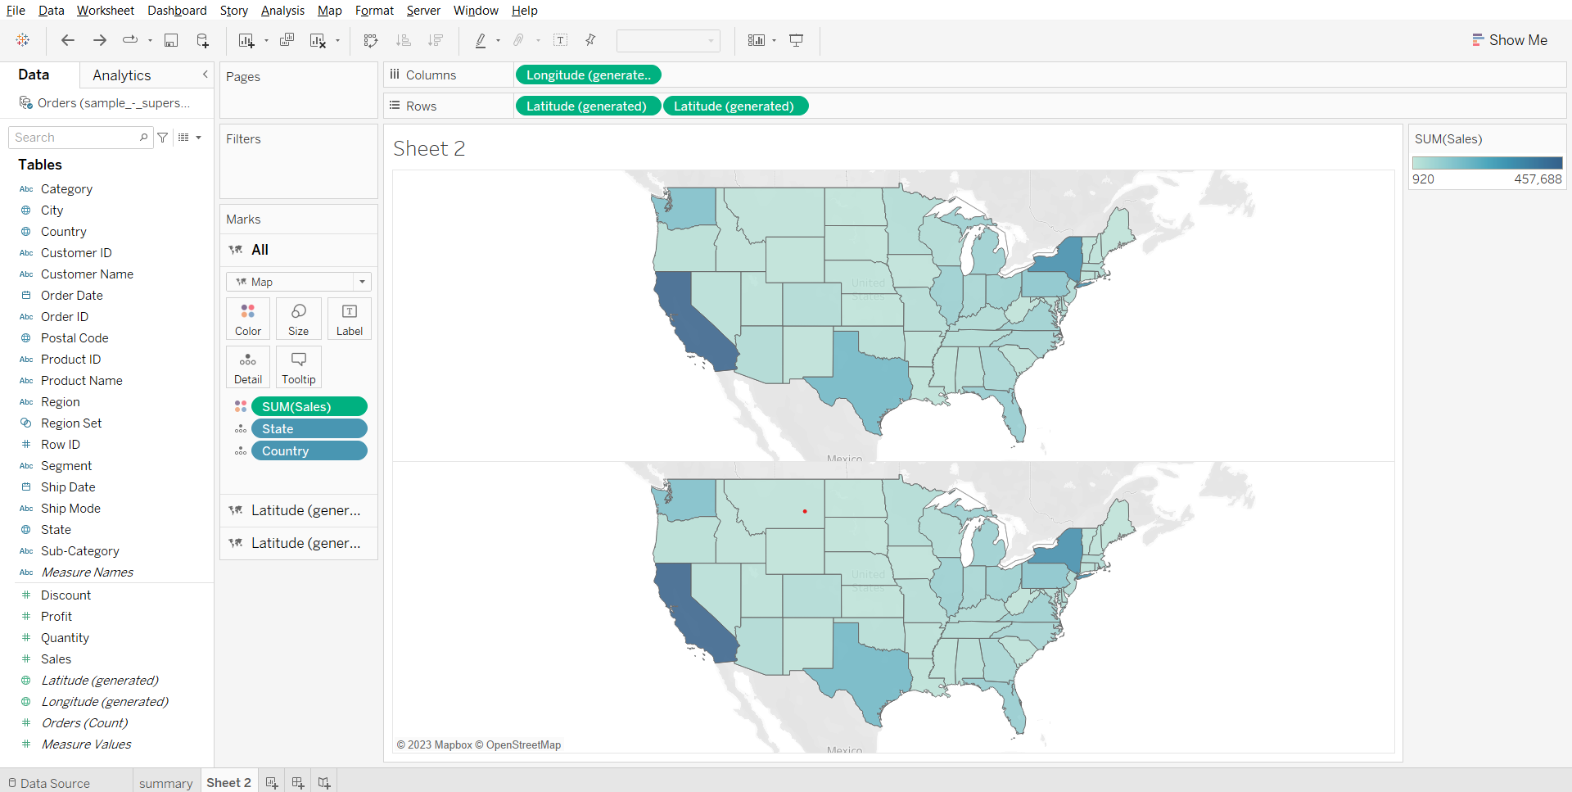

* Click on the second Latitude chart in the marks card.
* Remove sales, drop profit on size.
* Change mark type to circles.
* Click on color and choose black.
* Click on size and adjust the size of the circles.
* Open the latitude dropdown in the rows shelf and choose ‘Dual Axis’.

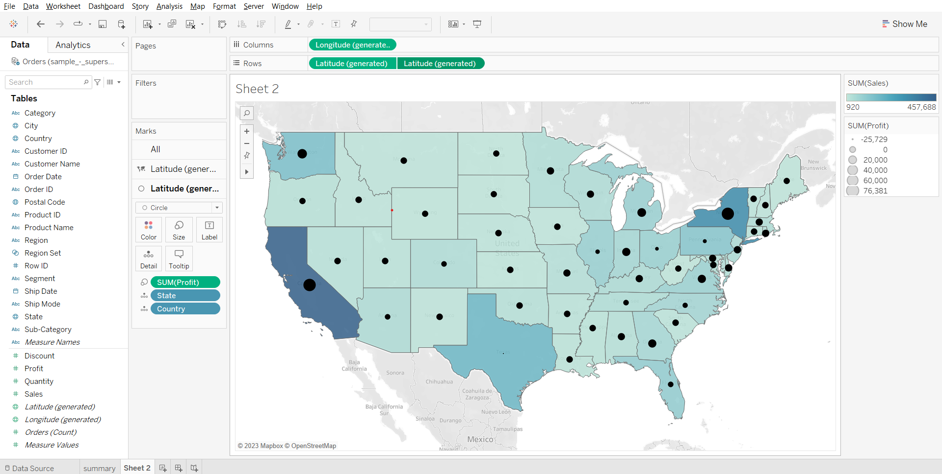

From the plot we can see that Texas has the lowest profit compared to the rest of the states.

**Adding a filter for order date :**

* Drag order date to filter card, select year, click next, select ‘use all’, click OK.

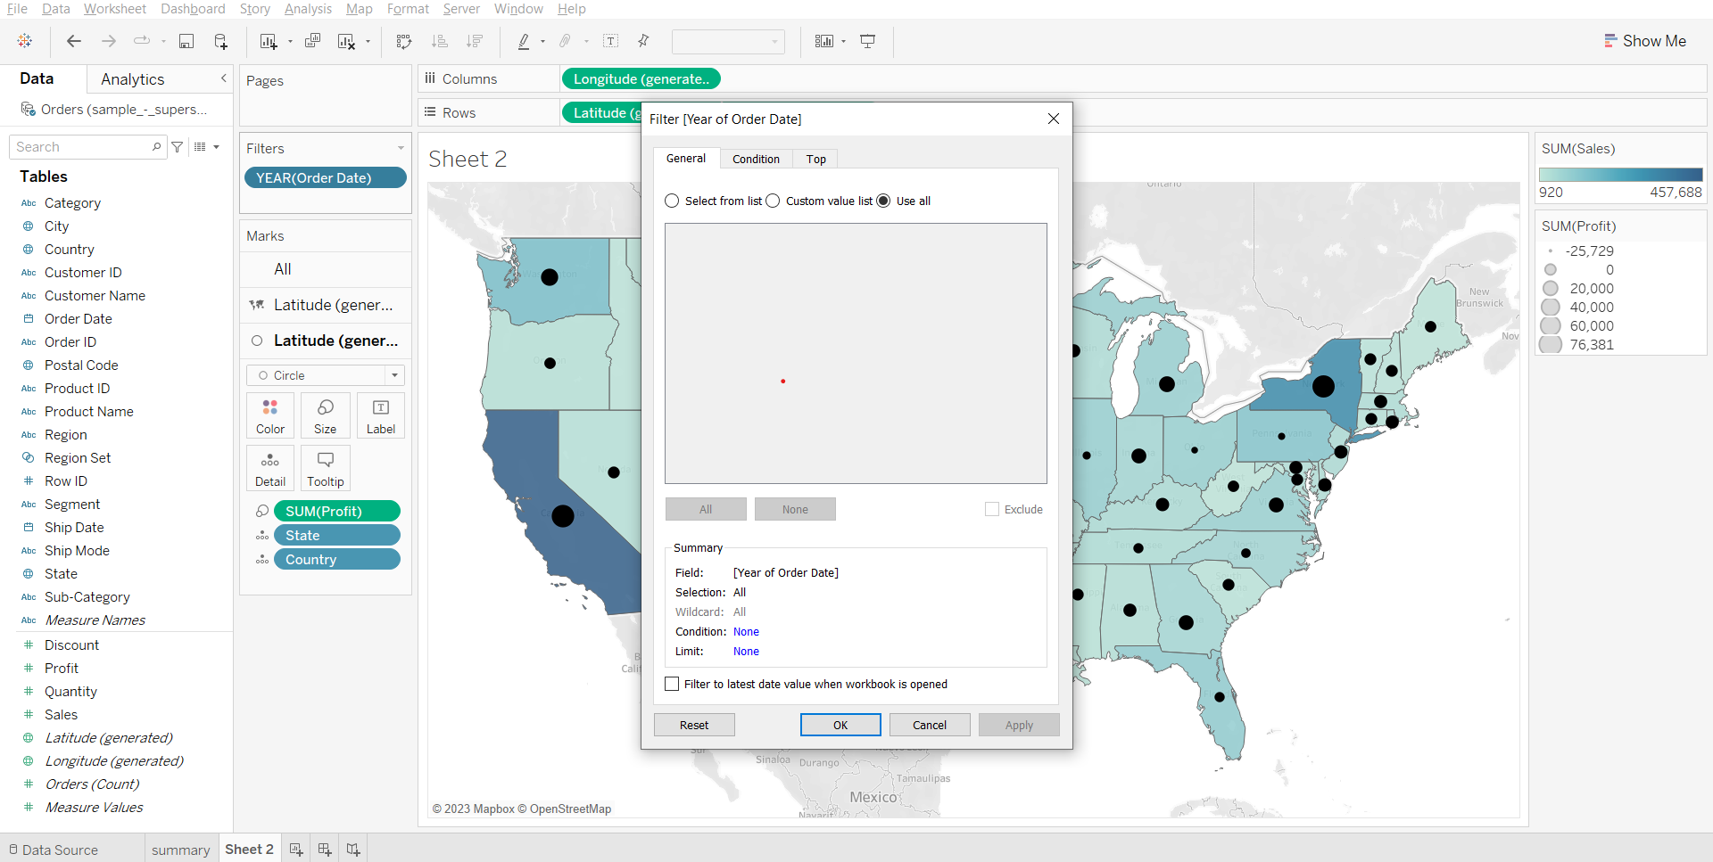

**Sheet 3 -**Subcategory wise profit and sales.

* Drag category and sub-category to rows, drop sales on color, profit on size, adjust size as per need.
* Change fit to entire view, right click on header in sheet, remove header labels.

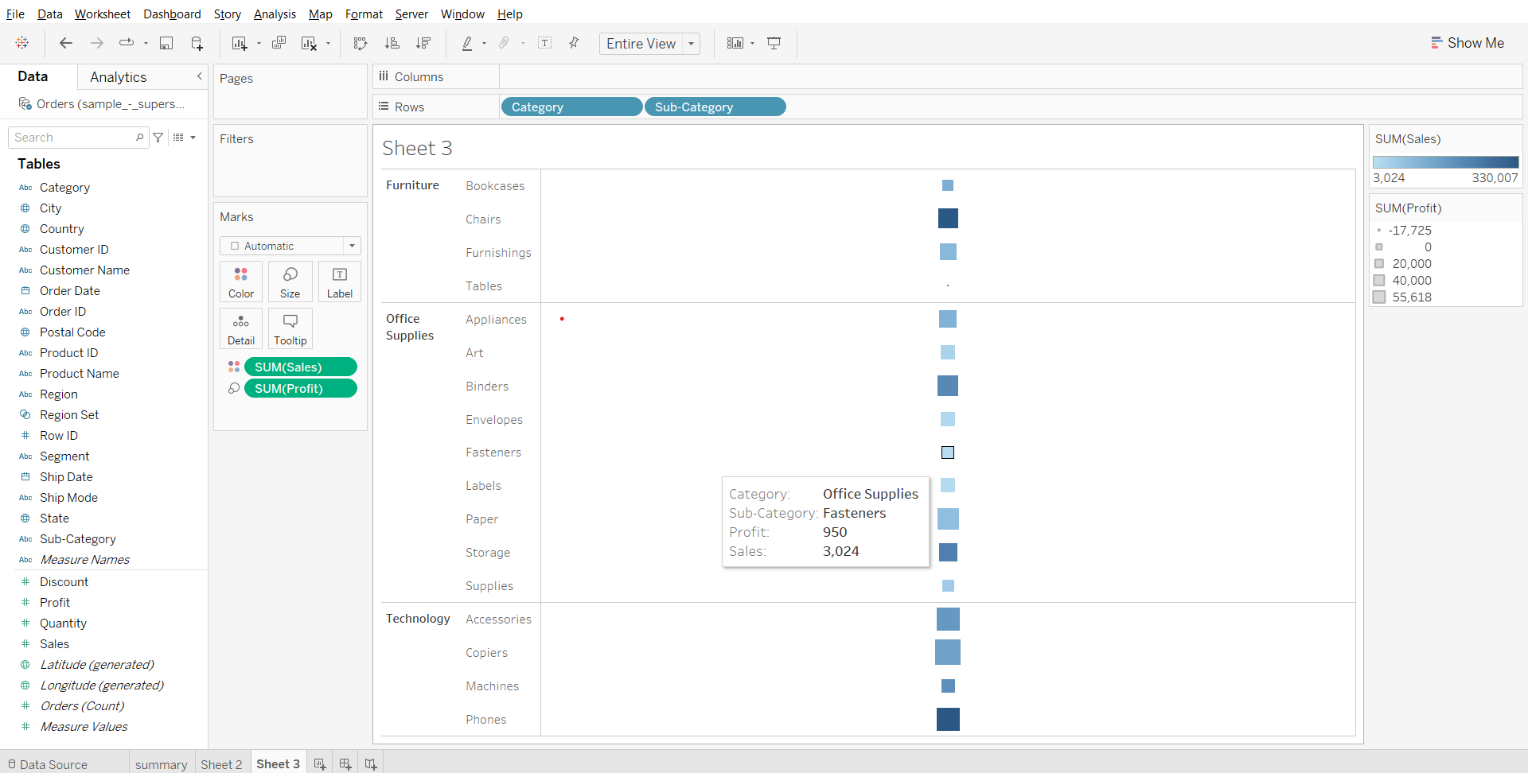

From the above dashboard we can see that for the state of Texas we have negative profit and for subcategory we have the negative profit so let’s analyze further why this is so.

**Adding order date filter for the dashboard :**

* Create a new dashboard, set size to automatic, drop all 3 sheets on the canvas as shown in the screenshot below, open sheet 2 menu (from top right corner of sheet 2 container), select filters > year of order date.
* Right click on the filter and choose a single value slider. Open the menu from the filter container, select Apply to worksheets > All using this data source.

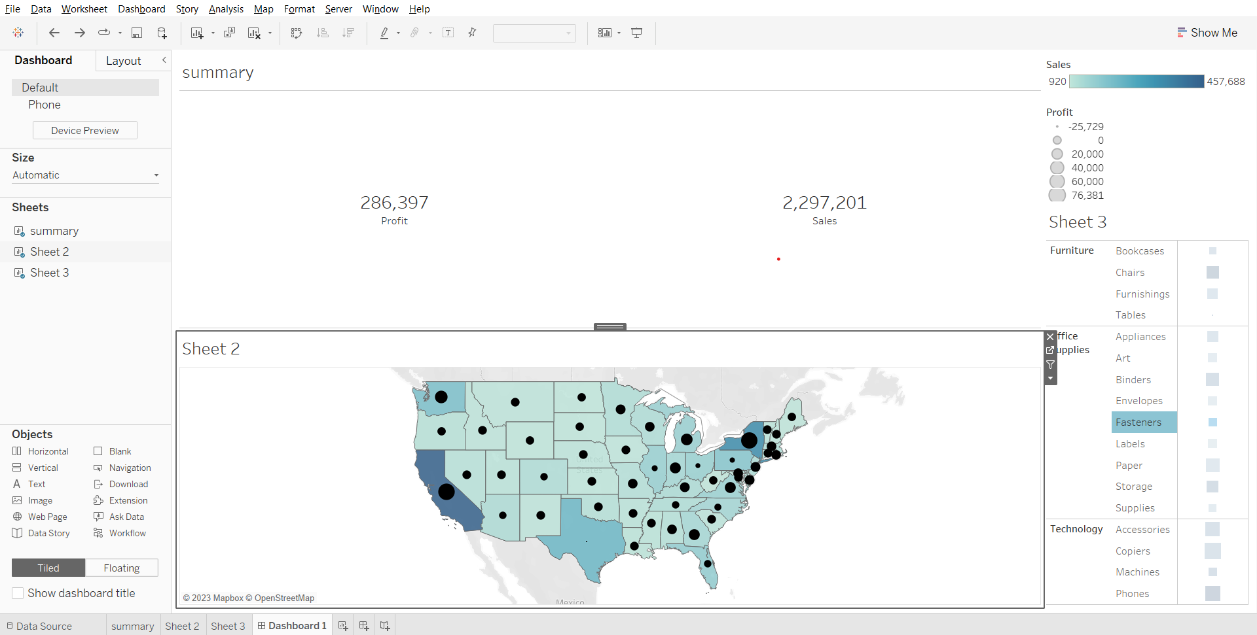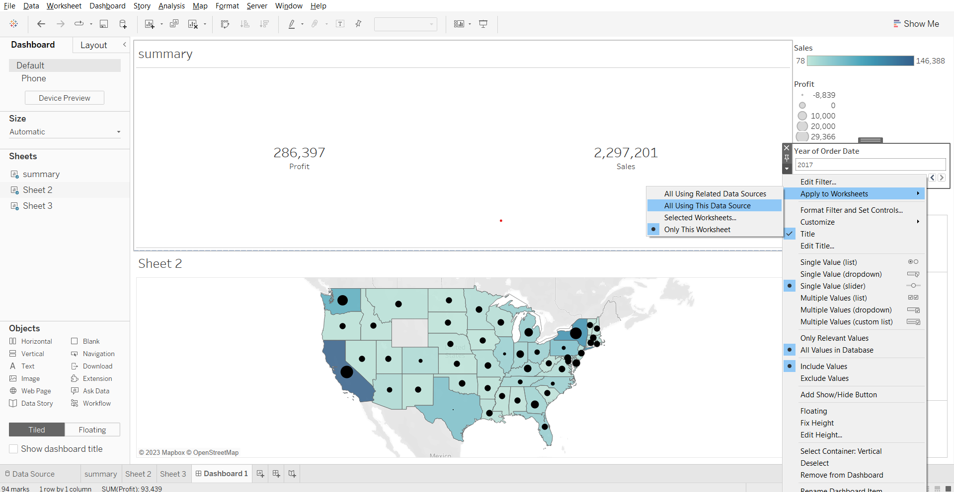

**Note: Keep the Order date filter field to All** for further analysis.

* Selecting State-Texas and Subcategory-Table and profit field for further analysis

**Sheet 4 -**  
Plotting city wise profit for the state of Texas.

* Drag state to filter, select Texas, click OK. Drag city to rows, profit to columns, profit to color. Change fit to the entire view.

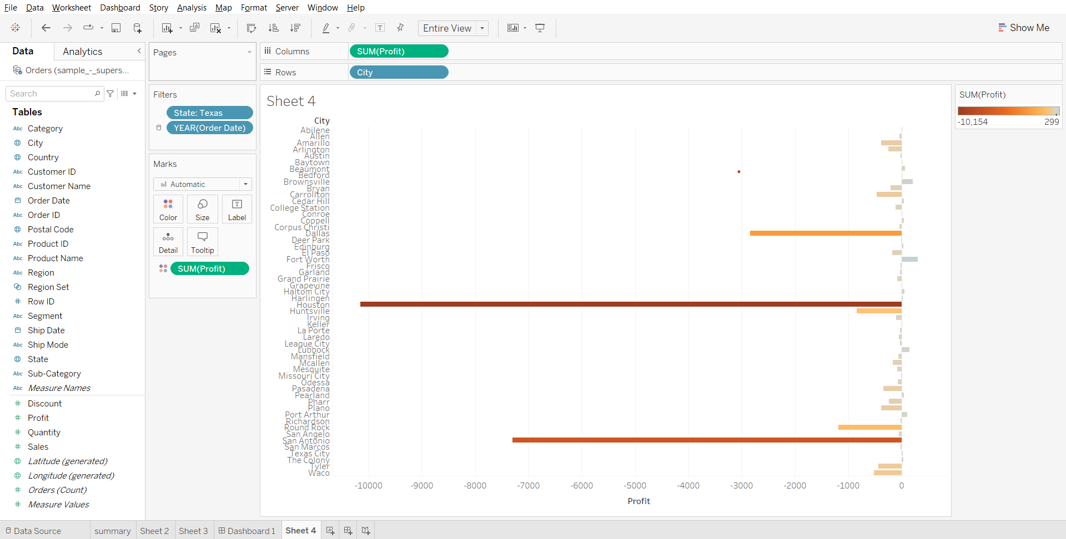

We can see that the city Houston is where we are losing more money.

**Showing city interactive filter :**

* Open the State menu in the filter card, choose show filter.
* Convert the checklist into a single value dropdown.

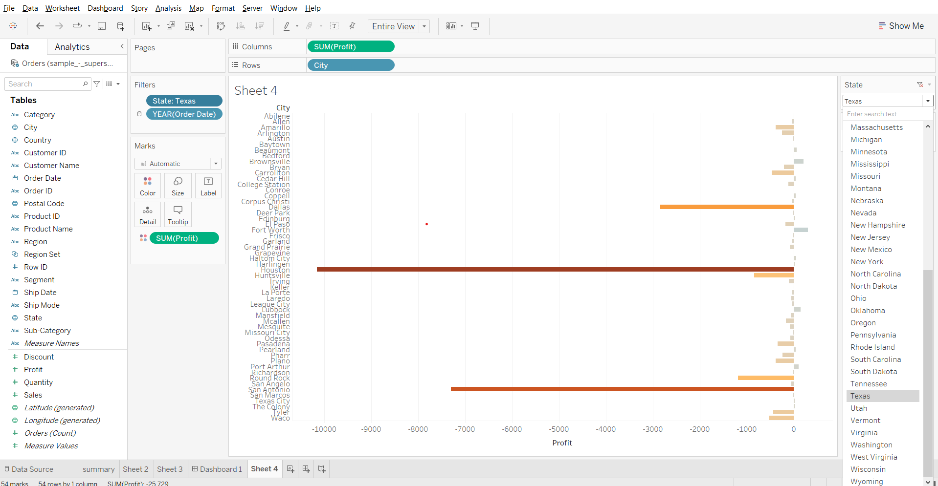

**Sheet 5 -**

* Drag subcategory to rows, profit to columns. Drag state to filters, select Texas, click ok.
* From the State dropdown in filters, add it to context. Drag city to filters, from dropdown select show filter, convert the checklist to a single value dropdown. Drag Profit to color.
* From city dropdown select Houston.

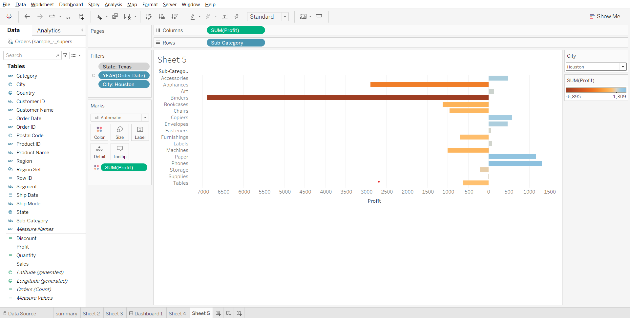

We can see that for city houston we are losing more money in subcategory binders.

**Creating a dashboard :**

* Create a new dashboard, set size to automatic, drop sheet 4 and sheet 5 on the canvas. Hide title for both sheets.

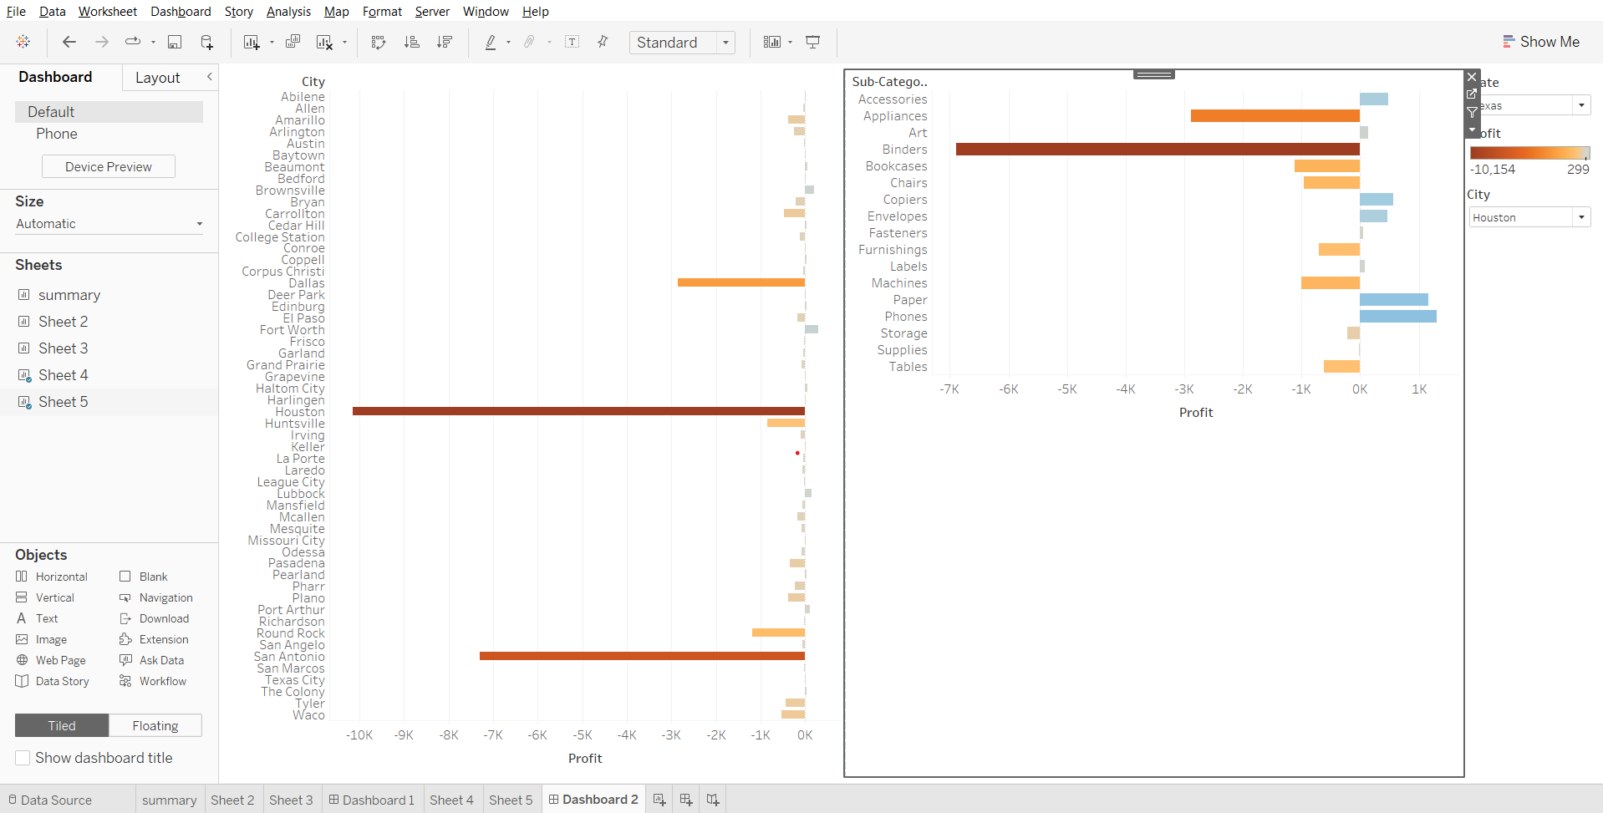

So we can see that for the state of Texas in the city of Houston we are losing money in subcategory binder so let’s further analyze exactly which product we are losing money in.

**Sheet 6 -**Creating products wise profit for city houston and subcategory binders.

* Drag product name to rows, add all members. Drag profit to columns, drag city to filters, select houston, click OK.
* Drag subcategory to filters, select binders, click OK. Drag profit to color, change fit to Entire View.

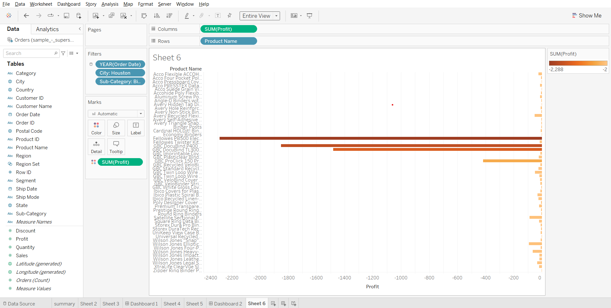

So we can see that within binders there are 3 products where we are losing more money, mainly there are binding machines. Let’s analyze why that is so.

**Sheet 7 -**Plotting average discount vs profit for each product within subcategory binder and for city houston.

* Duplicate sheet 6, rename it as Sheet 7, drag discount to columns before profit. Change its measure to average.
* From discount marks cards, remove profit from color.

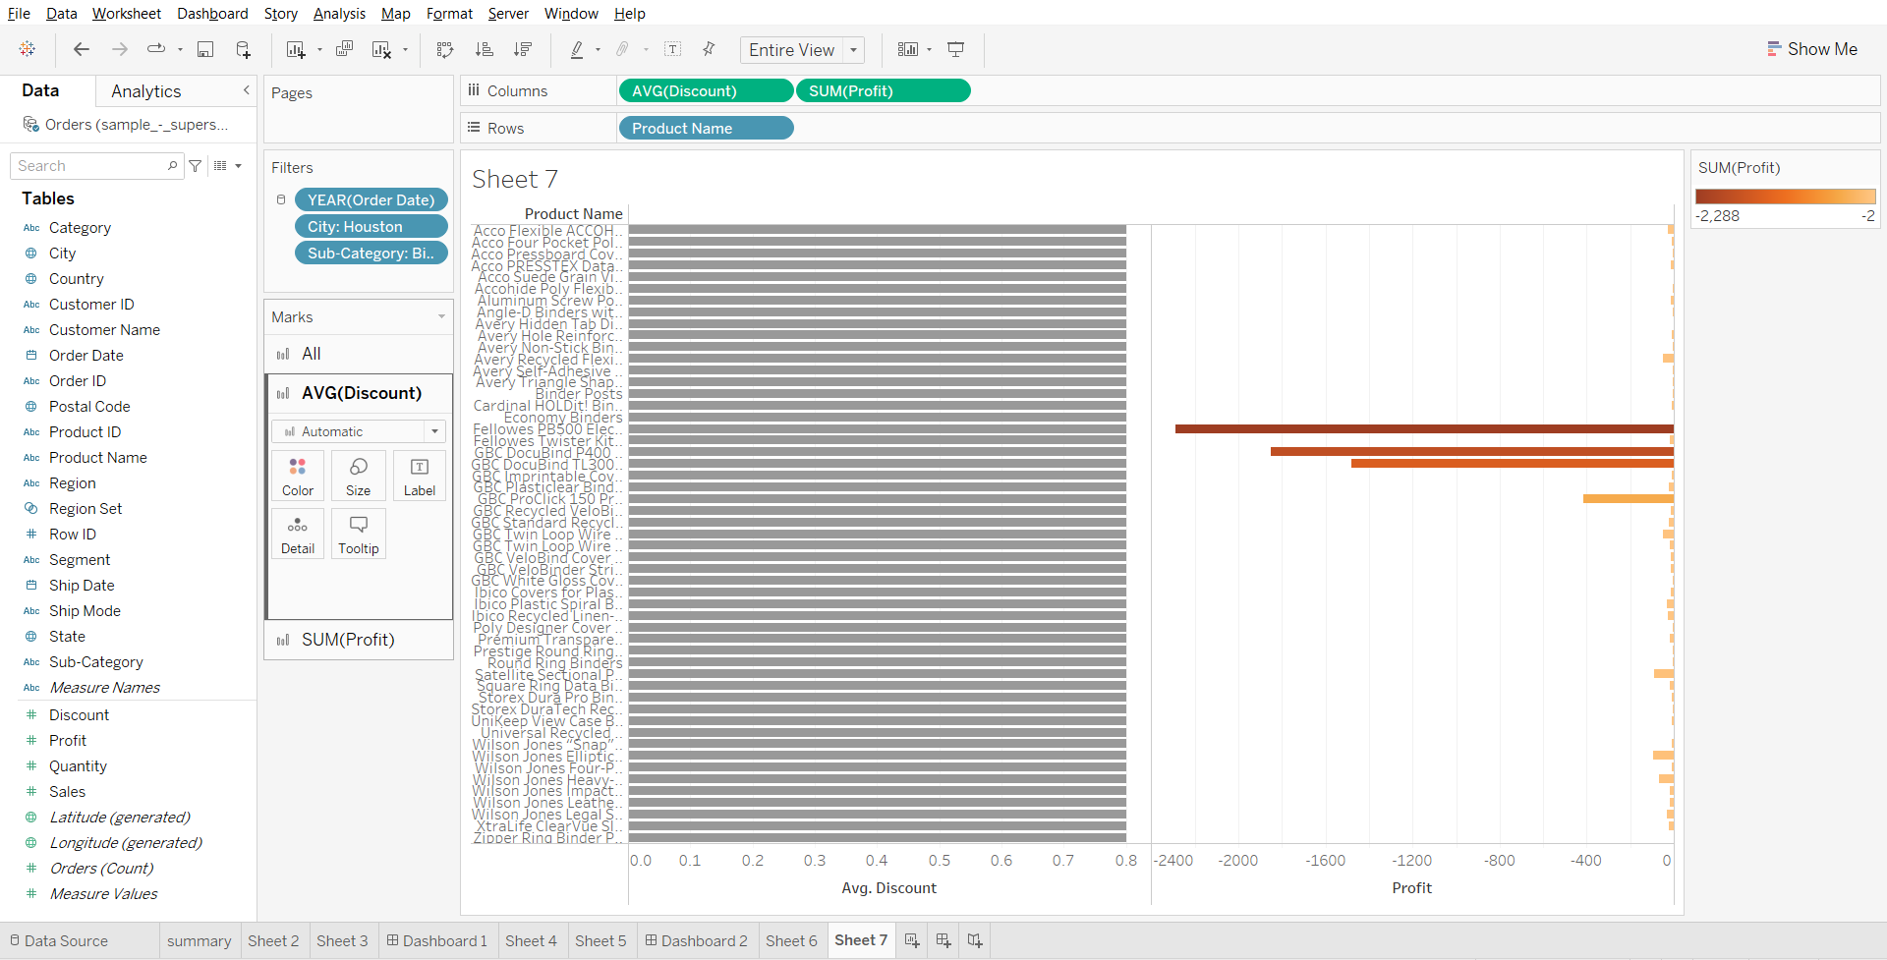

So we can see that for city houston and for subcategory binders all the products have an average discount of 0.8 or 80% on them which is why the store in houston is losing more money in houston city.

**Creating a story for above analysis:**

The 1st tab is the sales and profit summary for the US.

* Create a new story, add dashboard 1 to the canvas, set size to automatic, write ‘Summary’ in caption

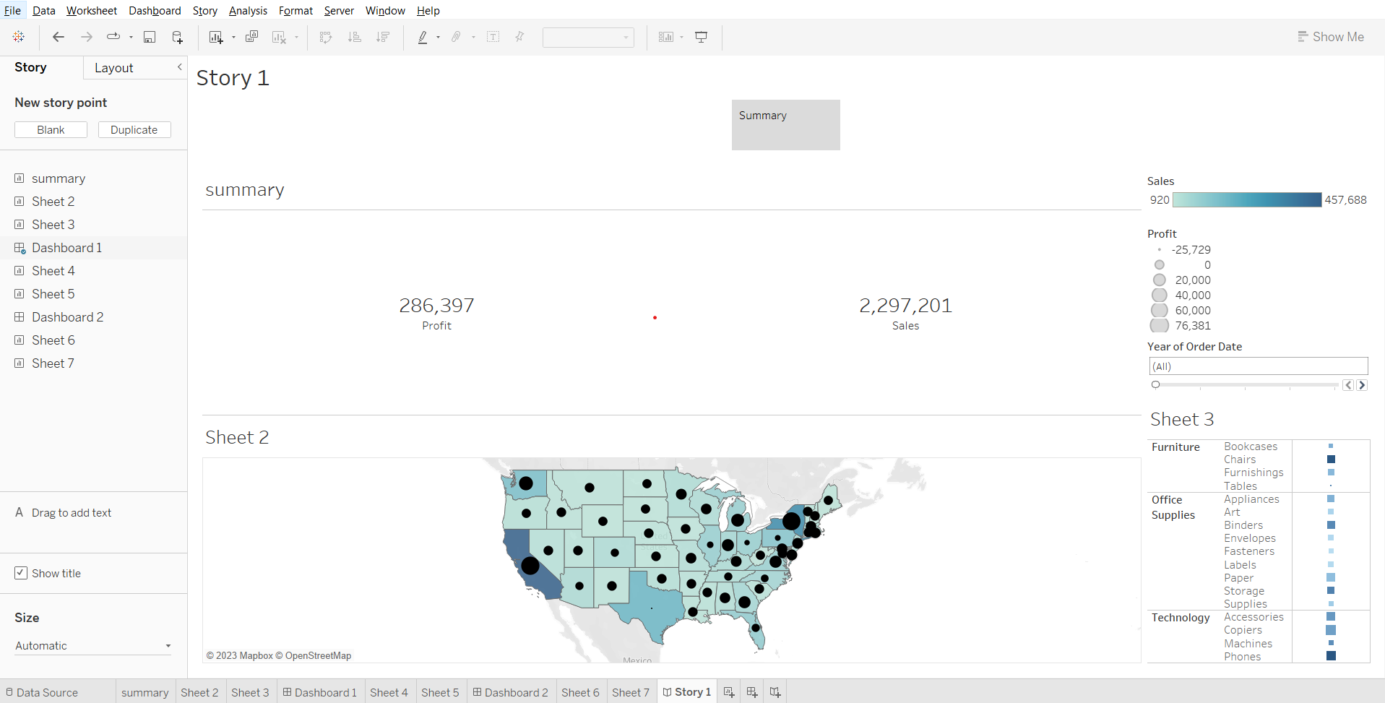

The 2nd tab is analyzing what went wrong in Texas.  
So we can see that for city Houston and for the binder subcategory we are losing money.

* Creak a new story point, write ‘What went wrong in Texas’ as caption, drag dashboard 2 to the canvas.

The 3rd tab we are diving deeper to find for which products are we losing money for Houston city and Binders category.

* Create a new story point, type ‘Product wise analysis’ in caption, drag sheet 6 to the canvas.

We can see that almost all the products that come under the Binder category are losing money.  
So let see why is that so?

* Create a new story point, type ‘Why so?’ in the caption and drag sheet 7 to the canvas.

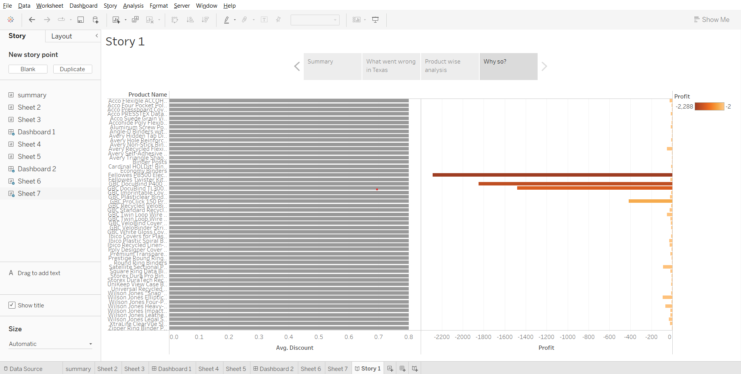

So we can see that for all the products that are there in subcategory binder and for city Houston it is giving an average discount of 0.8 or 80% which is why it is losing more money compared to other subcategories.

To publish the workbook, press Ctrl + S, sign in, name the workbook.

### 

### **How to increase efficiency of Tableau Dashboards**

* Your data strategy drives performance
  + Minimize the number of fields
  + Minimize the number of records
  + Optimize extracts
* Reduce the marks (data points) in your view
  + Practice guided analytics.
  + Remove unneeded dimensions
  + Explore.
* Limit your filters by number and type
  + Reduce the number of filters in use.
  + Use an include filter
  + Use a continuous date filter.
  + Use Boolean or numeric filters.
  + Use parameters and action filters.
* Optimize and materialize your calculations
  + Perform calculations in the database.
  + Reduce the number of nested calculations.
  + Reduce the granularity of LoD or table calculations in the view. The more granular the calculation, the longer it takes.
    - LoDs
    - Table Calculations
  + Where possible, use MIN or MAX instead of AVG.Make groups with calculations.
  + Use Booleans or numeric calculations instead of string calculations.
* Take advantage of Tableau’s query optimization
  + Blend on low-granularity dimensions.
  + Minimize joined tables.
    - Assume referential integrity
  + Remove custom SQL.
* Clean up your workbooks
  + Reduce dashboard scope.
  + Delete or consolidate unused worksheets and data sources.

### 

### **Box and Whiskers plot**

* Also called as Boxplot
* Used to plot a distribution of values for a selected measure
* The Box contains the lower quartile,upper quartile and the median in the center
* You can configure the Upper and lower lines called as whiskers to be to be within 1.5 times the Interquartile range or all the points at the maximum extent of the data
* [Building blocks for Box and Whisker plot](https://help.tableau.com/current/pro/desktop/en-us/buildexamples_boxplot.htm#:~:text=The%20basic%20building%20blocks%20for%20a%20box%20and%20whisker%20plot%20are%20as%20follows%3A)

**Business problem 1:**Compare the average discount given to each segment across various regions.

* Creating a bar chart for each region and segment
  + Drop segment and region on columns, drop discount on rows. Change the measure of discount to average.
* Creating a Box and whiskers plot
  + Go to ‘show me’, click on box and whiskers plot
* Solving the business problem
  + Change format of vertical axis values to percentage, drag region from marks card to columns.
  + Go to Analysis in the menu bar, uncheck aggregate measures.

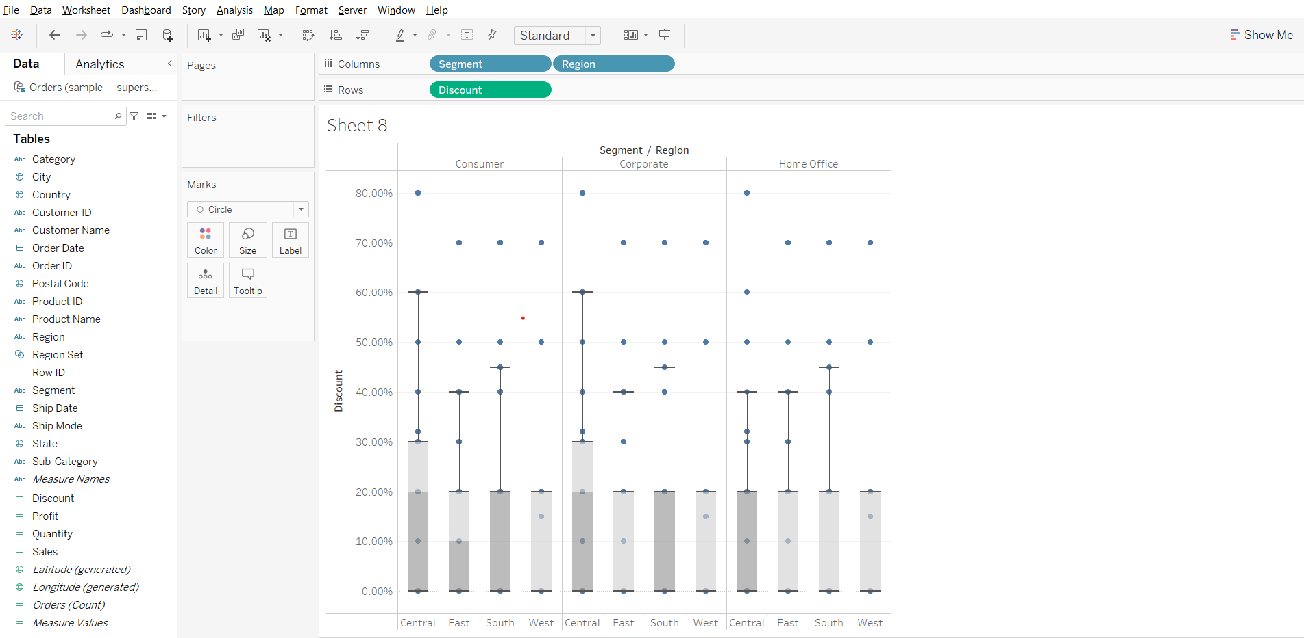

**Insight:** We can see that the median discount value for west region for all the segments is 0 we can say that west region has lowest discount values compared to other region for each segment

You can edit the properties of the box and whiskers plot by right clicking on one of the boxes in the plot and clicking on Edit…

### 

### **Bullet chart**

* A bullet graph is a bar marked with extra encodings to show progress towards a goal or performance against a reference line.
* A bullet graph is useful for comparing the performance of a primary measure to one or more other measures.

**Business problem 2:**Compare 2017 and 2016 sales for each product subcategory.

* First we will create two calculated fields to get 2016 sales and 2017 sales.

Sales 2016= IF YEAR([Order Date])=2016 THEN [Sales] END  
Sales 2017= IF YEAR([Order Date])=2017 THEN [Sales] END

* Create a bullet chart using the show me card
  + Drop sales 2016, sales 2017 on columns, subcategory on rows
  + Go to show me and select the bullet chart, change fit to the entire view.
* Editing the properties of bullet chart  
  Changing the vertical reference bands to display total sales in 2017
* Right click on the horizontal axis, choose Edit reference line > Average sales 2017
* Change measure to total, click OK.

Change the background bars from 60, 80 to 25, 50, 75 % of sales in 2017, here the blue bars denote the total sales in 2016.

* Right click on the horizontal axis, go to Edit reference line > 60%, 80% of Average S…
* Change percentage values to 25, 50, 75. Change measure to total. Click ok.

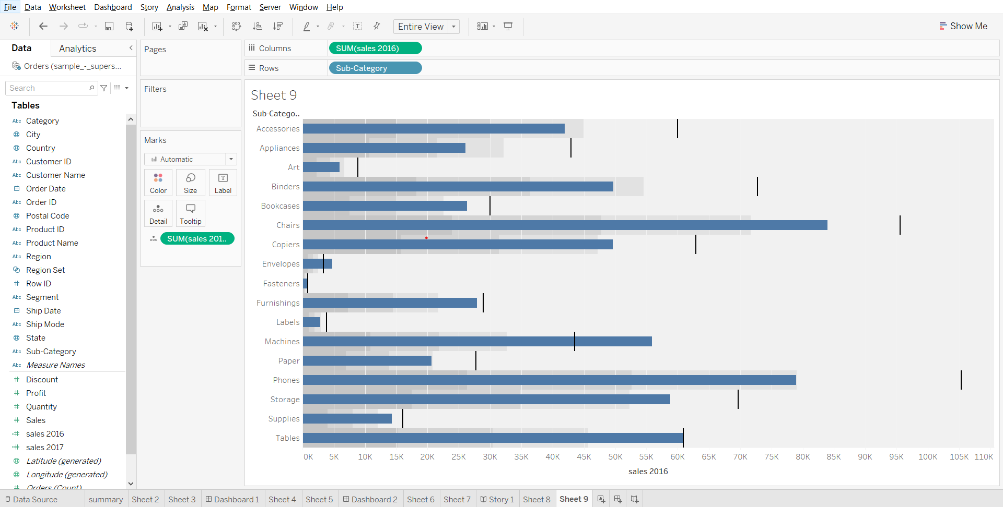

We can swap the reference lines so that the blue bars represent sales in 2017 and the vertical reference line and the background will represent 25,50 and 75% of total sales in 2016.  
To do so, right click on the horizontal axis, choose ‘swap reference lone fields’.

### 

### **Tableau Capstone Project introduction**

Doc: [link](https://docs.google.com/document/d/1oQ9A4fYhPeiU_i_cBm6RMWbxwMTSrNOBYsJJppTs-dQ/edit?usp=sharing)

1. You’ll get assignment questions on this case study under the homework section from the first lecture of Excel.
2. You do not have to submit this project and there is no specific evaluation that will be done for the case study as of now.
3. You are not allowed to share this data publicly as it contains sensitive information about the company.
4. If you have created a dashboard and want to save it then you can upload the same on tableau public then download it on to your local system and delete the dashboard from tableau public website.
5. You are not allowed to showcase this project in your resume. What you can do is take a dataset that is publicly available and showcase that as a project in your resume.